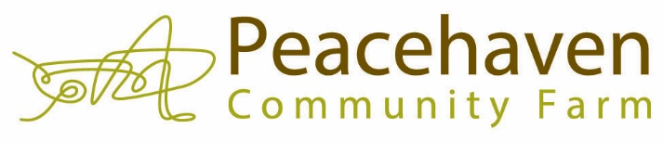
1458 NC Highway 61, Greensboro, NC 27377
DONATION/PLEDGE FORM
Please print and complete this form and mail it along with your contribution to the address listed above.
Make checks, corporate matches or other gifts payable to Peacehaven Community Farm.
Contact Marylang.mcdade@peacehavenfarm.org with any questions.
DONOR INFORMATION – Your gift is tax deductible.
Name_______________________________________________________________ Phone______________________
Billing Address____________________________________________________________________________________
City_______________________________________________ State_________________________ Zip_____________
Email address/es__________________________________________________________________________________
By providing this email address, I authorize Peacehaven to contact me about news, events and volunteer opportunities at the farm.
_____ I/we wish to have our donation remain anonymous
This gift is made: In Honor of___________________________________________________________________________
This gift is made: In Memory of_________________________________________________________________________
To whom should we send the acknowledgement of your honorary/memorial donation? Name/Address/City/State/Zip___________________________________________________________________
___________________________________________________________________________________________
Yes! I want to support Peacehaven Community Farm.
Please visit www.peacehavenfarm.org to set up your monthly gift or one-time gift by credit/debit card or e-check. When giving online, this donation form is not necessary.
I want to become a Peacehaven Cultivator by making a monthly gift of:
___ $10/mo ___$25/mo ___$50/mo ___$75/mo ___$100/mo ___$ Surprise us!
I want to make a one-time gift of:
Amount enclosed ___$1000 ___$500 ___$250 ___$100 ___$50 ___$ Surprise us!
_____ I want to make a gift of stock. Please contact me.
_____ I want to leave a bequest to Peacehaven. Please contact me.
_____ My employer will match my gift.

Peacehaven Community Farm is a 501c3 non-profit organization.

