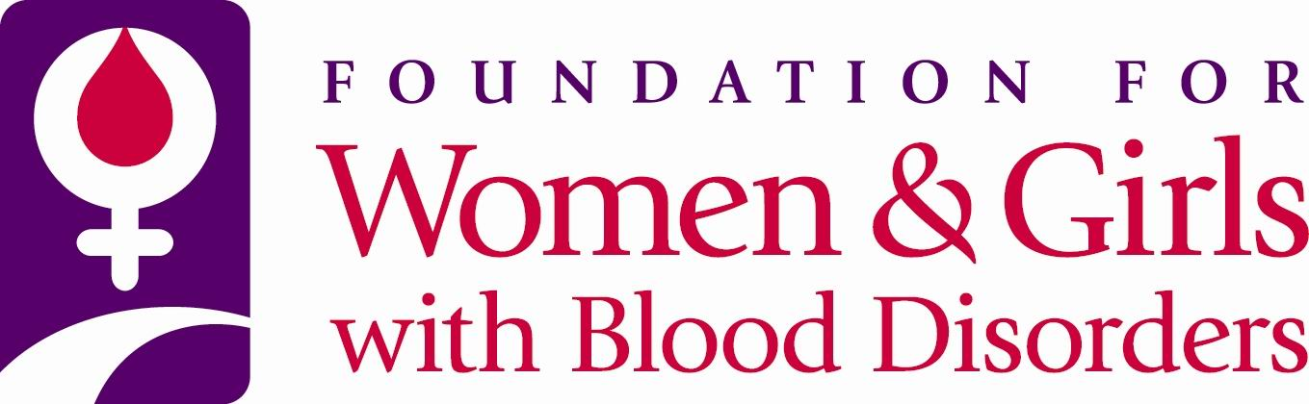

FWGBD Research Grant
Promoting XXcellence in Women’s Health:
Optimal Management of Women and Girls with Blood Disorders

2022 Special Award Focus Area: Bleeding Disorders Affecting Women and Girls

CONTACT INFORMATION – Please include contact information for the applicant and mentor:

NAME:

ACADEMIC TITLE:

POSITION:

MAILING ADDRESS (including City, State and Zip Code):

EMAIL ADDRESS:

MOBILE NUMBER:

MENTOR NAME:

ACADEMIC TITLE:

HOME DEPARTMENT:

LOCAL ADDRESS (including City, State and Zip Code):

E-MAIL ADDRESS:

MOBILE NUMBER:

PROJECT TITLE:

SYNOPSIS OF PROPOSAL: (Use only the space provided – minimum 11-point Arial font)

PENDING IRB APPROVAL:

SIGNATURES OF APPROVAL

I certify that the information presented in this proposal is, to the best of my knowledge, complete, accurate, and developed according to practices commonly accepted within the scientific community. In addition, I understand that I will be expected to meet regularly with my mentor, and accept and provide feedback.

Signature of Applicant Date

I have reviewed this application and hereby take responsibility for mentoring the applicant in the execution of the research project, should this project be funded. I recommend that this application be submitted.

Signature of Mentor Date

REMINDERS

Once completed, this form serves as the cover for your application; elements are described in the RFA.

Merge all documents into a single PDF and submit by 11:59 PM EDT on September 9, 2022, to:
kfunkhouser@fwgbd.org, with the subject heading “FWGBD 2022 Special Research Award Application.”

Failure to follow these directions will result in the proposal being returned to you, without review. Do not include appendices.

APPLICATION DEADLINE: September 9, 2022, by 11:59 PM EDT

Notification of Awards: December 2, 2022

