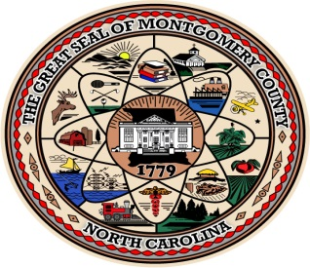 MONTGOMERY COUNTY
BOARD OF ELECTIONS

RESOLUTION TO CONDUCT ONE STOP
EARLY VOTING IN MONTGOMERY COUNTY, NC

WHEREAS, The Montgomery County Board of Elections met on July 17, 2018 and discussed the One Stop early voting locations and hours.

WHEREAS, The Montgomery County Board of elections determined that the last Saturday of Early voting the turn out would be greater. Hours needed to be extended.

BE IT RESOLVED, that the Montgomery County Board of elections met on July 17, 2018 and unanimously voted to conduct One Stop early voting in two locations, the Montgomery County Library located 215 W. Main St. Troy, NC and at the Biscoe Town Hall located at 110 W Main St Biscoe, NC. Monday, October 17 thru Friday, October 19. Monday, October 22 thru October 26. Monday October 29 thru November 2 from 7am. until 7pm. Saturday, November 3 from 8am until 5pm.

This the 17th Day of July 2018

Montgomery County
Board of Elections

___________________
John Adams, Chairman

ATTEST:

______________________
Curt Carter, Member

_______________________
Mary Cagle, Member

_______________________
Dree Wynkoop, Member

