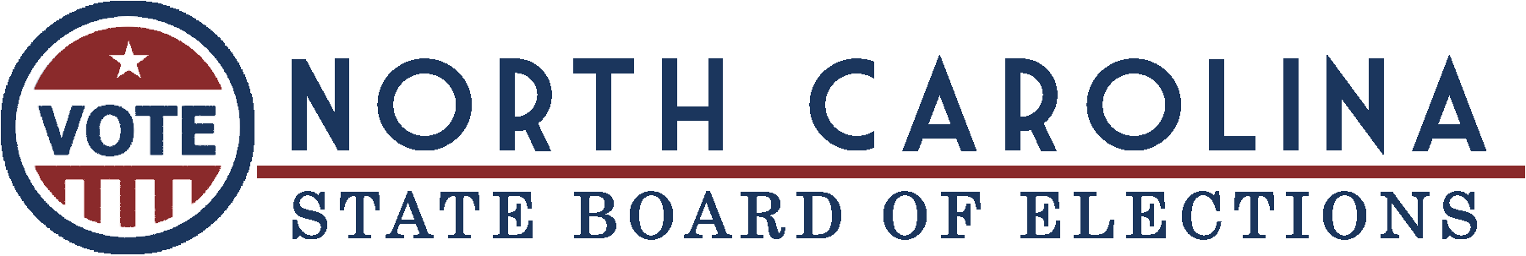

 | FOR IMMEDIATE RELEASE  Friday, January 31, 2025 |  |  | Patrick Gannon, Public Information Director  Email

New Photo ID Approval Period Begins for 2025 and 2026 Elections

Raleigh, N.C. — The State Board of Elections encourages eligible educational institutions and government agencies to apply to have their student and employee photo IDs approved for voting purposes in 2025 and 2026 elections in North Carolina.
All previous ID approvals expired on December 31, 2024. The State Board will accept applications for new ID approvals from February 1 through April 1.
To request approval for use in the 2025 municipal elections and 2026 primary and general elections, an institution must provide a signed approval form and a digital image of the ID card to the State Board on or before April 1, 2025. This year in North Carolina, municipal elections will be held in September, October, and November. Next year, the primary is in March and general election is in November.
Previously approved student or employee ID cards may not require an entirely new request for approval. If an institution’s IDs (1) were approved by the State Board in 2023 or 2024, (2) contain an expiration date, and (3) have had no changes to the card since its approval, the institution will simply select the “Statement of No Changes” box on the approval form. No new digital image is required for an approved card with no changes.
Public colleges and universities may seek approval of both student and employee ID cards, but they must submit separate approval forms for each type of ID.
See the links below for submission instructions and ID approval request forms:
- 2025 Employee ID Application Instructions (PDF)
- 2025 Student ID Application Instructions (PDF)
- 2025 Employee ID Approval Request Form (fillable PDF)
- 2025 Student ID Approval Request Form (fillable PDF)
The Board will review submissions to ensure they comply with criteria in state law in April 2025, then publish a list of approved ID cards. Cards approved by the State Board will remain valid for use as a voter’s photo ID through December 31, 2026.
"In the last election cycle, more than 100 educational and government institutions had their IDs approved for voting purposes, and we hope that number increases in 2025,” said Karen Brinson Bell, executive director of the State Board of Elections. “The State Board is ready to assist these schools and government agencies as they work through the approval process.”
Photo ID Background
Voters in North Carolina are asked to present photo identification to vote. For more information on the photo ID requirement, see Voter ID.
Student identification cards issued by North Carolina public or private universities and colleges, as well as employee identification cards issued by state and local government entities and charter schools, are valid forms of photo ID for voting when approved by the State Board.
Many other types of photo ID, including driver’s licenses, also are accepted for voting.
State Board staff are in contact with education, employer, and advocacy partners to ensure details of the approval process are shared with all institutions.
Educational institutions and government agencies with questions about the process should email VoterID@ncsbe.gov or call (919) 814-0700.

###



Unsubscribe
This message was sent to rhonda.johnson@montgomerycountync.gov from ncsbe.comms@ncsbe.gov
NC State Board of Elections
North Carolina State Board of Elections (NCSBE)

