POLL PLACE SCANNER AND TABULATOR

DS200®
The DS200 is a poll place ballot scanner and vote tabulator that combines the flexibility and efficiency of digital-imaging technology to support paper-based voting — taking traditional optical-scan ballot vote tabulation into the twenty-first century.
Security features:
- Physical and System Access Controls
- Audit Logs
- Proprietary Flash Drives
- System Application Controls
- Encryption, Hash Validation and Digital Signatures

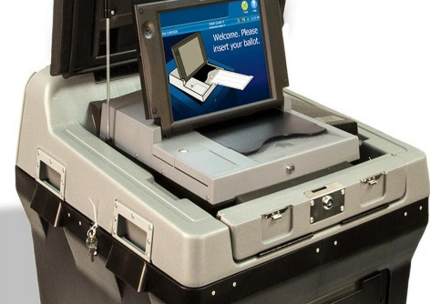

UNIVERSAL VOTING SYSTEM

ExpressVote®
The paper-based ExpressVote Universal Voting System uses touch-screen technology that produces a paper record for tabulation. As a marker, the ExpressVote handles the entire marking process, eliminating unclear marks and the need for interpretation of the voter’s mark.
Security features:
- Physical and System Access Controls
- Verifiable Paper Record
- Audit Logs
- Proprietary Flash Drives
- System Application Controls
- Encryption, Hash Validation and Digital Signatures

