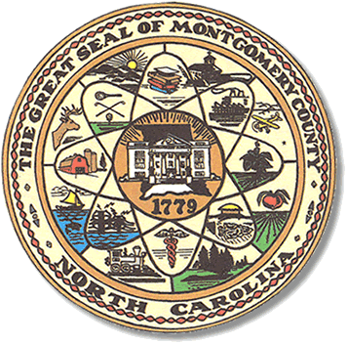

Montgomery County
Board of Elections

Mary Cagle, Chairman
John Adams, Vice Chair
Demond Hairston, Secretary

Dree Wynkoop, Member
Debbie Burris, Member

BOARD MEETING MINUTES

MAY 12, 2020
5:30 p.m.

The Montgomery County Board of Elections (BOE) meet Tuesday May 12, 2020 at 5:30 p.m. at the BOE Office at 327 Main St in Troy, NC. Present were: Dree Wynkoop, Demond Hairston, Debbie Burris, Mary Cagle and John Adams. Also present was the Director of Elections, Rhonda Johnson, and Deputy Director Kim Batten.

Mary Cagle called the meeting to order at 5:32 p.m.

There was no public comment to be heard.

The meeting room and board members were following safety guide lines due to the Corona virus. The board meeting room was cleaned prior to the members entering. The board members were asked to wear masks. Hand sanitizer was on the table. Each member sat 6’ apart from each other.

John Adams made a motion to approve the minutes and Mary Cagle seconded the motion. All in favor.

Rhonda Johnson gave out the new law books 2019 edition.

Rhonda Johnson gave everyone a memo from Karen Brinson Bell explaining what the CARES Act Grant is and how it would be distributed to each county. The grant money is being given to each county due to the Corona virus and the effect is will have on voters and election staff needs to stay safe.

On that note, the Board moved on to the next item on the agenda.

Soil and Water filing will began on June 8 – July 2. Rhonda Johnson advised there is usually just one person filing for this office.

Rhonda Johnson went on to say the State board is anticipating an increase in Absentee ballots because of the pandemic and that we may need to bring in additional workers and poll workers. With that said, Rhonda Johnson did a recruitment memo to put in the Post Office and Tax Dept.

And finally, on the agenda is looking ahead to One Stop location and hours. Locations and hours must be turned in in July and there may be some changes for the election due to the Corona virus.

With no further business at hand, John Adams motioned to adjourn the meeting with a second from Dree Wynkoop. All in favor and the meeting adjourn at 5:47 p.m.

________________________________________ CHAIRMAN

________________________________________ VICE CHAIR

________________________________________ SECRETARY

________________________________________ MEMBER

________________________________________ MEMBER
Montgomery County Board of Elections

