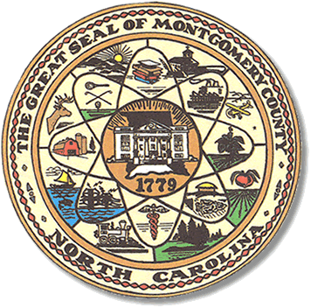

Montgomery County
Board of Elections

Mary Cagle, Chairman
John Adams, Vice Chair
Demond Hairston, Secretary

Dree Wynkoop, Member
Debbie Burris, Member

BOARD MEETING MINUTES

September 8, 2020
5:30 p.m.

The Montgomery County Board of Elections (BOE) meet Tuesday July 21, 2020 at 5:30 p.m. at the BOE Office at 327 Main St in Troy, NC. Present were: Dree Wynkoop, Demond Hairston, Debbie Burris, Mary Cagle and John Adams. Also present was the Director of Elections, Rhonda Johnson, and Deputy Director Kim Batten.

Mary Cagle called the meeting to order at 5:32 p.m.

There were no minutes to approve.

No public comments.

Rhonda Johnson submitted a resolution to the board members that would allow absentee ballots to be opened and placed into the M100 tabulator at each absentee meeting. The totals would not be ran until Election night. This process will save time for the board members and staff during the election night meeting.
Dree Wynkoop motioned to accept and all were in favor.

Rhonda also advised the board that the office would be purchasing a letter opener to handle all the absentees received. With the record number of absentee envelopes the board will have to open. Most counties across the state are buying the same letter opener. This will be purchased with the CARES act funds. The board requested a list of Cares act expenditures.

Rhonda Johnson advised the PPE supplies for the precincts will we be delivered sometime next week.

With no further business at hand, and no other comments. John Adams motioned to adjourn the meeting with a second from Dree Wynkoop. All in favor and the meeting adjourn at 5:54 p.m.

________________________________________ CHAIRMAN

________________________________________ VICE CHAIR

________________________________________ MEMBER

________________________________________ MEMBER

________________________________________ MEMBER
Montgomery County Board of Elections

