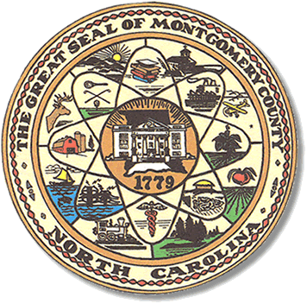

Montgomery County
Board of Elections

Mary Cagle, Chairman
John Adams, Vice Chair
Demond Hairston, Secretary

Dree Wynkoop, Member
Debbie Burris, Member

BOARD MEETING MINUTES

September 29, 2020
5:00 p.m.

The Montgomery County Board of Elections (BOE) met Tuesday September 29, 2020 at 5:02 p.m. at the BOE Office at 327 Main St in Troy, NC. Present were: Dree Wynkoop, Demond Hairston, Debbie Burris, Mary Cagle and John Adams. Also present was the Director of Elections, Rhonda Johnson, and Deputy Director Kim Batten.

John Adams called the meeting to order at 5:04 p.m.

There were 4 people in public comments section: Jennifer Thompson, Jim Otis, Lawrence Hammond, & Shirley Harris.

Dree Wynkoop motioned the September 8, 2020 minutes be approved. Mary Cagle seconded the motion. All approved and the motion carried.

Rhonda Johnson explained the absentee ballot process.

There were 296 absentee ballots to be reviewed and approved. Dree Wynkoop called out the names, John Adams checked off the list. Each board member reviewed the ballot. Once all ballots were approved Dree Wynkoop and Demond Hairston fed the ballots into the M100. There were 293 absentee ballots approved and 3 deficiencies.
Mary Cagle made motion to approve all 293 ballots and Demond Hairston seconded the motion.

With no further business at hand, John Adams motioned to adjourn the meeting with a second from Debbie Burris. All in favor and the meeting adjourned at 7:51p.m.

________________________________________ CHAIRMAN

________________________________________ VICE CHAIR

________________________________________ SECRETARY

________________________________________ MEMBER

________________________________________ MEMBER
Montgomery County Board of Elections

