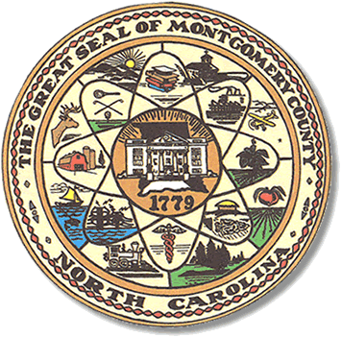

Montgomery County
Board of Elections

Mary Cagle, Chairman
John Adams, Vice Chair
Demond Hairston, Secretary

Dree Wynkoop, Member
Debbie Burris, Member

BOARD MEETING MINUTES

September 10, 2019
5:30 p.m.

The Montgomery County Board of Elections (BOE) met Tuesday, July 9, 2019 at 5:30 p.m. at the BOE Office at 327 Main St in Troy, NC. Present were: Dree Wynkoop, Demond Hairston, Debbie Burris, and Mary Cagle and John Adams. Also present was the Director of Elections, Rhonda Johnson, and Deputy Director Kim Batten.

Mary Cagle called the meeting to order at 5:34 p.m.

There were no public comments. With none, the board moved on to next item on agenda.

Dree Wynkoop motioned the July 2019 minutes be approved. Mary Cagle seconded the motion. All approved and the motion carried.

The board reviewed all ballots and there were no issues.

Rhonda Johnson advised the State Board had sent out mailer about Voter Id. Samples were shown to the board.

Rhonda Johnson sent out a memo advising who the One Stop Workers and dates for One Stop training.

Board has not had a raise in years and will discuss an increase at next meeting.

The board returned their notes on precinct lines. Rhonda Johnson put there notes together and submitted to the board. The deadline to send to State Board was Oct 1. Results will be given next meeting.

With no further business at hand, John Adams motioned to adjourn the meeting with a second from Dree Wynkoop. All in favor and the meeting adjourn at 6:06 p.m.

________________________________________ CHAIRMAN

________________________________________ VICE CHAIR

________________________________________ SECRETARY

________________________________________ MEMBER

________________________________________ MEMBER
Montgomery County Board of Elections

