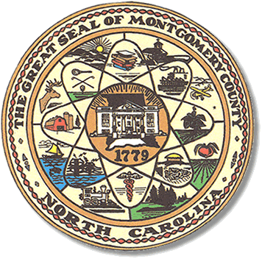

Montgomery County
Board of Elections

Mary Cagle, Chairman
John Adams, Vice Chair
Demond Hairston, Secretary

Dree Wynkoop, Member
Debbie Burris, Member

BOARD MEETING MINUTES

October 29, 2019
5:00 p.m.

The Montgomery County Board of Elections (BOE) met Tuesday, October 29, 2019 at 5:00 p.m. at the BOE Office at 327 Main St in Troy, NC. Present were: Dree Wynkoop, Demond Hairston, Debbie Burris, Mary Cagle and John Adams. Also present was the Director of Elections, Rhonda Johnson, and Deputy Director Kim Batten.

Mary Cagle called the meeting to order at 5:03 p.m.

There were no public comments. With none, the board moved on to next item on agenda.

Dree Wynkoop motioned the October 29, 2019 minutes be approved. Debbie Burris seconded the motion. All approved and the motion carried.

There was 1 absentee ballot returned and approved.

Rhonda Johnson announced two orders on redistricting had been issued. The first one a three-judge panel of Superior Court ruled that North Carolina’s congressional districts must be redrawn for the 2020 elections in a case challenging whether the 2016 districts are partisan gerrymanders. (The order is attached.)
The second one, the General Assembly is expected to redraw the districts, and importantly, the Court “retains jurisdiction to move the primary date for the congressional elections, or all of the State’s 2020 primaries, including for offices other than Congressional Representatives, should doing so become necessary to provide effective relief in this case.” (See p. 18 of the order.)

As of this meeting there have been 47 votes in-person and 2 absentees.

With no further business at hand, Dree Wynkoop motioned to adjourn the meeting with a second from Mary Cagle. All in favor and the meeting adjourn at 5:28 p.m.

________________________________________ CHAIRMAN

________________________________________ VICE CHAIR

________________________________________ SECRETARY

________________________________________ MEMBER

________________________________________ MEMBER
Montgomery County Board of Elections

