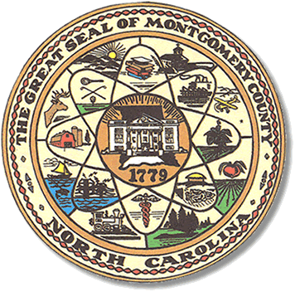

Montgomery County
Board of Elections

Mary Cagle, Chairman
John Adams, Vice Chair
Demond Hairston, Secretary

Dree Wynkoop, Member
Debbie Burris, Member

BOARD MEETING MINUTES

October 22, 2019
5:00 p.m.

The Montgomery County Board of Elections (BOE) met Tuesday, October 22, 2019 at 5:00 p.m. at the BOE Office at 327 Main St in Troy, NC. Present were: Dree Wynkoop, Mary Cagle and John Adams. Also present was the Director of Elections, Rhonda Johnson, and Deputy Director Kim Batten.

Mary Cagle called the meeting to order at 5:00 p.m.

There were no public comments. With none, the board moved on to next item on agenda.

Mary Cagle motioned the October 22, 2019 minutes be approved. John Adams seconded the motion. All approved and the motion carried.

There was 1 absentee returned and approved.

Rhonda Johnson went over the changes for absentees that begin this election. On the return envelope, in the Voter Assistant Certification section, the wording has changed so we apply a sticker provided by the State Board. Also we are required to keep a log of all absentees requested and all absentee ballots that have been returned.

The board signed the resolution for themselves to receive additional pay during election cycles. The resolution will be sent to the county commissioners for their review.

With no further business at hand, Dree Wynkoop motioned to adjourn the meeting with a second from Mary Cagle. All in favor and the meeting adjourn at 5:28 p.m.

________________________________________ CHAIRMAN

________________________________________ VICE CHAIR

________________________________________ SECRETARY

________________________________________ MEMBER

________________________________________ MEMBER
Montgomery County Board of Elections

