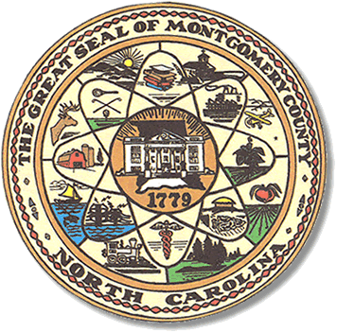

Montgomery County
Board of Elections

Mary Cagle, Chairman
John Adams, Vice Chair
Demond Hairston, Secretary

Dree Wynkoop, Member
Debbie Burris, Member

BOARD MEETING MINUTES

October 20, 2020
5:00 p.m.

The Montgomery County Board of Elections (BOE) met Tuesday October 13, 2020 at 5:00 p.m. at the BOE Office at 327 Main St in Troy, NC. Present were: Dree Wynkoop, Demond Hairston, Debbie Burris, Mary Cagle and John Adams. Also present was the Director of Elections, Rhonda Johnson, and Deputy Director Kim Batten.

John Adams called the meeting to order at 5:05 p.m.

John Adams made a motion to approve the minutes October 6th & 13th. Dree Wynkoop seconded the motion. All in favor.

Board started the absentee process. There were 174 civilian, 3 military and 1 overseas. Dree Wynkoop called out the names, John Adams checked off the list. Each board member reviewed the ballots. There were 5 ballots rejected. John Adams, Demond Hairston, and Debbie marked the military and overseas ballots. Once all ballots were opened Dree Wynkoop fed the ballots into the M100. There were 169 approved and 5 rejected. Cure letters will be sent to those voters. John Adams made motion to approve a 169 ballots and Mary Cagle seconded the motion.

There were 5 public attendees. Only 1 spoke. Constince Hernden asked how quickly
The BOE staff sent out cure letters on rejected absentee ballots. Rhonda informed Mrs.
Hernden that cure letters go out the very next morning after the absentee board meeting.

With no further business at hand, Mary Cagle motioned to adjourn the meeting with a second from Mary Cagle.

________________________________________ CHAIRMAN

________________________________________ VICE CHAIR

________________________________________ SECRETARY

________________________________________ MEMBER

________________________________________ MEMBER
Montgomery County Board of Elections

