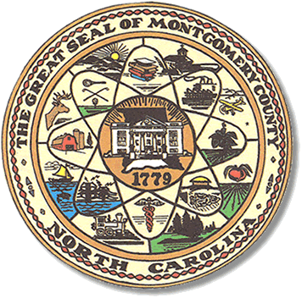

Montgomery County
Board of Elections

Mary Cagle, Chairman
John Adams, Vice Chair
Demond Hairston, Secretary

Dree Wynkoop, Member
Debbie Burris, Member

BOARD MEETING MINUTES

October 15, 2019
5:30 p.m.

The Montgomery County Board of Elections (BOE) met Tuesday, October 15, 2019 at 5:00 p.m. at the BOE Office at 327 Main St in Troy, NC. Present were: Dree Wynkoop, Demond Hairston, Debbie Burris, Mary Cagle and John Adams. Also present was the Director of Elections, Rhonda Johnson, and Deputy Director Kim Batten.

Mary Cagle called the meeting to order at 5:30 p.m.

No Absentee ballots were available for review by the board.

There were no public comments. With none, the board moved on to next item on agenda.

Dree Wynkoop motioned the September 2019 minutes be approved. Mary Cagle seconded the motion. All approved and the motion carried.

Rhonda Johnson gave the board members some examples from other counties of what board members were paid monthly. The board reviewed the examples and agreed that they want the county to give them a per meeting payment during the Election months of October and November. Dree made a motion for Rhonda to type a resolution for the County Manager and finance. Mary made a second motion. All approved and the motion carried.

After submitting their suggestions on precinct line changes or closings, the board tabled and will review again in ’20-’21.

With no further business at hand, John Adams motioned to adjourn the meeting with a second from Dree Wynkoop. All in favor and the meeting adjourn at 6:06 p.m.

________________________________________ CHAIRMAN

________________________________________ VICE CHAIR

________________________________________ SECRETARY

________________________________________ MEMBER

________________________________________ MEMBER
Montgomery County Board of Elections

