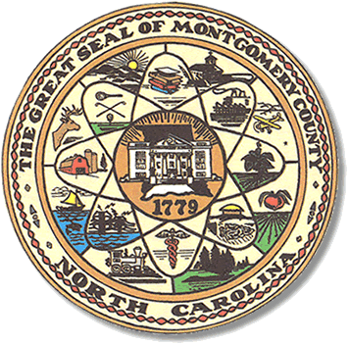

Montgomery County
Board of Elections

Mary Cagle, Chairman
John Adams, Vice Chair
Demond Hairston, Secretary

Dree Wynkoop, Member
Debbie Burris, Member

BOARD MEETING MINUTES

October 13, 2020
5:00 p.m.

The Montgomery County Board of Elections (BOE) met Tuesday October 13, 2020 at 5:02 p.m. at the BOE Office at 327 Main St in Troy, NC. Present were: Dree Wynkoop, Demond Hairston, Debbie Burris, Mary Cagle and John Adams. Also present was the Director of Elections, Rhonda Johnson, and Deputy Director Kim Batten.

John Adams called the meeting to order at 5:03 p.m.

There were no minutes to approve.

There were 6 people in public comments section. No one signed up to comment but there were 2 people who chose to speak openly to the board in an unprofessional manner.

Parker Holland, who is our district security and support technician, attended this board meeting.

Rhonda Johnson mentioned the poll workers would be receiving $100 bonus and this is an incentive for them to work as well as a thank you from the NC House and Senate.

Board started the absentee process. There were 148 civilian and 1 military. There were 149 absentee ballots to be reviewed. Dree Wynkoop called out the names, John Adams checked off the list. Each board member reviewed the ballot. Once all ballots were approved Demond Hairston and Dree Wynkoop fed the ballots into the M100. There were 149 approved. John Adams made motion to approve all 149 ballots and Mary Cagle seconded the motion.

With no further business at hand, Debbie Burris motioned to adjourn the meeting with a second from Mary Cagle.

________________________________________ CHAIRMAN

________________________________________ VICE CHAIR

________________________________________ SECRETARY

________________________________________ MEMBER

________________________________________ MEMBER
Montgomery County Board of Elections

