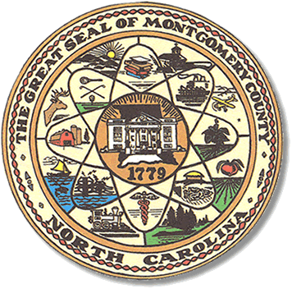

Montgomery County
Board of Elections

Mary Cagle, Chairman
John Adams, Vice Chair
Demond Hairston, Secretary

Dree Wynkoop, Member
Debbie Burris, Member

BOARD MEETING MINUTES

November 3, 2020
5:00 p.m.

The Montgomery County Board of Elections (BOE) met Monday November 3, 2020 at 5:00 p.m. at the BOE Office at 327 Main St in Troy, NC. Present were: Dree Wynkoop, Demond Hairston, Debbie Burris, Mary Cagle and John Adams. Also present was the Director of Elections, Rhonda Johnson, and Deputy Director Kim Batten.

John Adams called the meeting to order at 5:11 p.m.

John Adams made a motion to approve the minutes November 2, 2020. Mary Cagle seconded the motion. All in favor.

Board started the absentee process. There were 13 civilian, and 4 overseas with 1 rejected because it was not signed. Dree Wynkoop called out the names, John Adams checked off the list. Each board member reviewed the ballots. Once all ballots were opened Debbie Burris fed the ballots into the M100. There was a total 17 ballots approved and 1 ballot was rejected. John Adams made motion to approve a 17 ballots and Mary Cagle seconded the motion.

John Adams made the motion to close the poll for the Absentee Ballots. Dree Wynkoop seconded the motion. All in favor.

There were 4 public attendees.

With no further business, John Adams motioned to adjourn the meeting and Dree Wynkoop seconded the motion. All in favor. The meeting was adjourned at 9:30 p.m.

________________________________________ CHAIRMAN

________________________________________ VICE CHAIR

________________________________________ SECRETARY

________________________________________ MEMBER

________________________________________ MEMBER
Montgomery County Board of Elections

