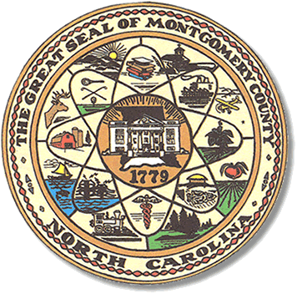

Montgomery County
Board of Elections

Mary Cagle, Chairman
John Adams, Vice Chair
Demond Hairston, Secretary

Dree Wynkoop, Member
Debbie Burris, Member

BOARD MEETING MINUTES
PROVISIONAL MEETING
November 12, 2020
5:30 p.m.

The Montgomery County Board of Elections (BOE) met Tuesday October 13, 2020 at 5:30 p.m. at the BOE Office at 327 Main St in Troy, NC. Present were: Dree Wynkoop, Debbie Burris, Mary Cagle and John Adams. Also present was the Director of Elections, Rhonda Johnson, and Deputy Director Kim Batten.

John Adams called the meeting to order at 5:30 p.m.

The board met today to review provisional ballots. There were 156 ballots to be reviewed. There were 48 approved, 4 partially approved, and 101 rejected.

There were 6 people in public comments section who only observed.

With no further business at hand, John Adams motioned to adjourn the meeting with a second from Mary Cagle.

________________________________________ CHAIRMAN

________________________________________ VICE CHAIR

________________________________________ SECRETARY

________________________________________ MEMBER

________________________________________ MEMBER
Montgomery County Board of Elections

