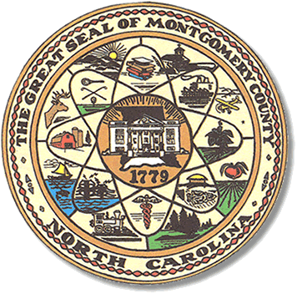

Montgomery County
Board of Elections

Karen Blair, Chairperson
John Adams, Vice Chair
Debbie Burris, Secretary

Dree Wynkoop, Member
Tasha Medley, Member

BOARD MEETING MINUTES
May 17, 2022
5:00 p.m.

The Montgomery County Board of Elections (BOE) met Tuesday, May 17, 2022 at
5:00 p.m. at the BOE Office at 327 Main St in Troy, NC. Present were: Dree Wynkoop, Debbie Burris, Karen Blair and John Adams. Also present were the Director of Elections, Rhonda Johnson and the Deputy Director Kim Batten.

Karen Blair called the meeting to order at 5:06 p.m.

The agenda was approved for the May 17, 2022 meeting. John Adams made a motion to approve the agenda and Debbie Burris seconded the motion. All were in favor.

The minutes 05/10 and 5/16 were signed but tabled until the next meeting.
No public comments.

There were 2 absentee ballots, 1 overseas ballot and 1 military ballot to review. A total of 2 absentee ballots were approved.

Due to retrieving a ballot for the board members to duplicate, at 5:24, John Adams motioned to defer the meeting. Tasha Medley seconded the motion. All were in favor and the meeting was deferred. The meeting will reconvene at 6:30 p.m.

The board reconvened at 6:30pm to duplicate the emailed military ballot. They also confirmed the totals and signed the absentee abstract. The meeting adjourned at 7:00pm.

________________________________________ CHAIR

________________________________________ VICE CHAIR

________________________________________ MEMBER

________________________________________ MEMBER

________________________________________ MEMBER
Montgomery County Board of Elections

