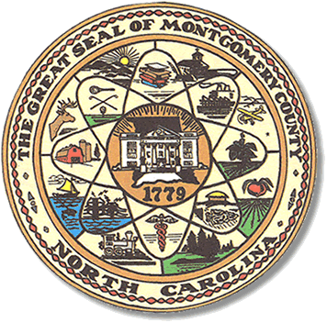

Montgomery County
Board of Elections

Mary Cagle, Chairman
John Adams, Vice Chair
Demond Hairston, Secretary

Dree Wynkoop, Member
Curtis Carter, Member

BOARD MEETING MINUTES

May 14, 2019
5:30 p.m.

The Montgomery County Board of Elections (BOE) met Tuesday, April 14, 2019 at 5:30 p.m. at the BOE Office at 327 Main St in Troy, NC. Present were: John Adams, Dree Wynkoop, Debbie Burris, and Mary Cagle. Also present was the Director of Elections, Rhonda Johnson and Deputy Director Kim Batten.

John Adams called the meeting to order at 5:45 p.m.

There was no public comment. With none, the board moved on to next item on agenda.

Dree Wynkoop motioned the April 2019 minutes be approved. John Adams seconded the motion. All approved and the motion carried.

Rhonda Johnson advised the board that precinct changes had been placed on hold by the State. Until the census is completed in 2020 there could be no changes to the precincts. The group went on to discuss which precincts they thought would be changed due to the increase of the population of that area.

Rhonda Johnson talked to the board members about the new voter ID machine. All 100 counties will be making voter photo ID’s for individuals that do not have one, effective May 2019. Rhonda showed the group a sample of what a Voter I.D. card looks like. There will be a seminar in August 2019 to introduce the new Voter I.D. program to the public. Rhonda Johnson stressed to the board that the program is geared toward people who do not have any identification however anyone can ask and obtain a photo ID.

Rhonda Johnson announced the State Board had appointed Karen Brinson Bell as the Board’s new executive director. Kim Westbrook Strach served as executive director since 2013.

With no further business at hand, Dree Wynkoop motioned to adjourn the meeting with a second from John Adams. All in favor and the meeting adjourn at 6:09 p.m.

________________________________________ CHAIRMAN

________________________________________ VICE CHAIR

________________________________________ SECRETARY

________________________________________ MEMBER

________________________________________ MEMBER
Montgomery County Board of Elections

