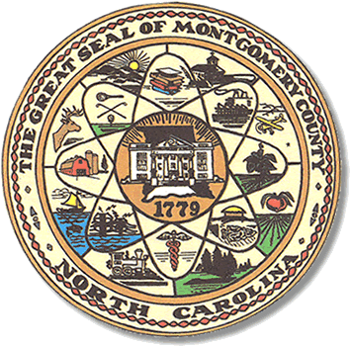

Montgomery County
Board of Elections

Mary Cagle, Chairman
John Adams, Vice Chair
Vacant, Secretary

Dree Wynkoop, Member
Debbie Burris, Member

BOARD MEETING MINUTES
March 9, 2021
5:30 p.m.

The Montgomery County Board of Elections (BOE) met Tuesday, March 9 at 5:30 p.m. at the BOE Office at 327 Main St in Troy, NC. Present were: Dree Wynkoop, John Adams, Debbie Burris, Demond Hairston and Mary Cagle. Also present was the Director of Elections, Rhonda Johnson, and Deputy Director Kim Batten.

John Adams motioned to call the meeting to order at 5:30 p.m. Debbie Burris seconded the motion.

Dree Wynkoop motioned to approve the minutes and Debbie Burris seconded the motion. All in favor.

Demond Hairston announced he would be moving to Greenville, NC and this would be his last meeting.

Rhonda Johnson advised that Executive Director, Karen Bell at the State Board was trying to get the NC Election Committee to move 2021 Municipal Elections and the March 2022 Primary to May 2022. This would cause the July Municipal filing and the
December Primary filing to be moved to 2022.

C.D Crepps informed Rhonda Johnson that Kenneth Blake could no longer be paid as a contracted person and an hourly person. After explaining what Kenneth does for the Board of Elections, the board asked Rhonda to get together a break out of what Kenneth does and come up with a fee for the tasks. The board asked Rhonda Johnson to get all the information together for the next meeting.

With no further business at hand, Dree Wynkoop motioned to adjourn the meeting with a second from Demond Hairston. All in favor. The board adjourned at 6:05 p.m.

________________________________________ CHAIRMAN

________________________________________ VICE CHAIR

________________________________________ SECRETARY

________________________________________ MEMBER

________________________________________ MEMBER
Montgomery County Board of Elections

