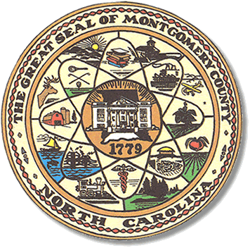

Montgomery County
Board of Elections

Mary Cagle, Chairman
John Adams, Vice Chair
Demond Hairston, Secretary

Dree Wynkoop, Member
Curtis Carter, Member

BOARD MEETING MINUTES

March 12, 2019
5:30 p.m.

The Montgomery County Board of Elections (BOE) met Tuesday, March 12, 2019 at 5:30 p.m. at the BOE Office at 327 Main St in Troy, NC. Present were: John Adams, Dree Wynkoop, and Demond Hairston. Also present was the Director of Elections, Rhonda Johnson and Deputy Director Kim Batten. Mary Cagle and Curtis Carter were not in attendance.

John Adams called the meeting to order at 5:30 p.m.

John Adams called for any public comment. With none, the board moved on to next item on agenda.

Dree Wynkoop motioned the December and February minutes be approved. Demond Hairston seconded the motion. The motion carried.

With legislation recently passing Voter ID laws, all county Board of Election offices will be making photo ID cards for the voters without identification. Montgomery County election office will host two seminars for the public providing the place and the tools for said meeting. The state board will provide the team to educate the public on Voter ID and answer questions. The meetings must be completed by 09/01/2019. Voters ID cards may be used beginning with the March 2020 Primary.

With no further business at hand, Dree Wynkoop made a motion to adjourn the meeting with a second from Demond Hairston. All are in favor and the meeting was adjourned at 6:10 p.m.

________________________________________ CHAIRMAN

________________________________________ VICE CHAIR

________________________________________ SECRETARY

________________________________________ MEMBER

________________________________________ MEMBER
Montgomery County Board of Elections

