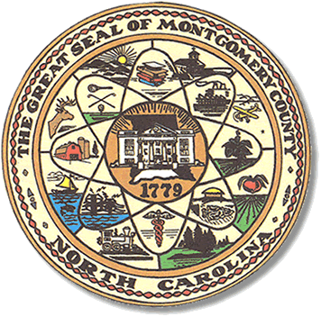

Montgomery County
Board of Elections

Karen Blair, Chairperson
John Adams, Vice Chair
Debbie Burris, Secretary

Dree Wynkoop, Member
Tasha Medley, Member

BOARD MEETING MINUTES
June 13, 2023
5:30 p.m.

The Montgomery County Board of Elections (BOE) met June 13, 2023, at
5:30 p.m. at the BOE Office at 327 N. Main St in Troy, NC. Present were Dree Wynkoop, Debbie Burris, Karen Blair and John Adams. Also present was the Director of Elections, Rhonda Johnson and Kim Batten, Deputy Director.

Karen Blair called the meeting to order at 5:32 pm.

The agenda was approved for the meeting. John Adams made the motion to approve the agenda and Debbie Burris seconded the motion. All were in favor.

The minutes from June 13, 2023, were approved with a motion from John Adams and a second from Dree Wynkoop. All were in favor.

Rhonda read the directors report for the board and informed them that she had emailed the party chairs two reports for precinct official appointment information. One report was of who was appointed in 2021-2023. The other report was of precinct officials that actually appeared to work the last election. She informed the board that she has added voter ID information to the county website. She informed the board that she and Kim had attended a luncheon provided by the county as a thank you for your hard work.
She informed the board that she has emailed the voter ID information to the Montgomery Herold, the Speckled Paw newsletter in Mt. Gilead, town of Biscoe newsletter and the WJRM radio station in Troy. She informed the board that she had emailed the Courier Tribune about running voter ID information and possibly part of our election ads in November 2023. The courier is getting together some quotes for the election ads. She informed the board that the hotel rooms are all booked for the August conference in Concord, NC.

Karen Blair asked that we attach the Directors Report topics to the monthly agenda.
Everyone agreed.

Old Business

After reviewing the report from Homeland Security in the May business meeting, the board signed a resolution to correct BOE office safety vulnerabilities.

Vice Chairperson vote was tabled till July meeting.

Rhonda told the board about the 2023-2024 fiscal budget for the election office.
She explained the process in which the county obtains the budget. She explained that she is given a spread sheet from the county finance office. She has to put a dollar amount in the spreadsheet for the things she needs in the office for the election. She has to put an explanation on the spreadsheet as to what it’s for or if it needs to increase, why. The spreadsheet has codes for each election item. Most of the items have an amount already prefilled in by the finance office. Such as postage, transportation and moving, telephones, copier rental etc. The county figures the biggest percent of our budget.

The board voted to combine the July11 business meeting and the swearing in of the July 18th 2023-2025 board meeting. Karen Blair asked for a motion. Dree Wynkoop gave the motion and Tasha Medley seconded the motion.

New Business

Rhonda Johnson advised that candidate filing would be July 7- 21st for Biscoe, Candor and Mt. Gilead.

With no further business at hand, and no other comments, Karen Blair called for a motion to adjourn. Dree Wynkoop moved to adjourn the meeting with a second from Tasha Medley. All were in favor and the meeting was adjourned at 6:22 p.m.

________________________________________ CHAIR

________________________________________ VICE CHAIR

________________________________________ MEMBER

________________________________________ MEMBER

________________________________________ MEMBER
Montgomery County Board of Elections

