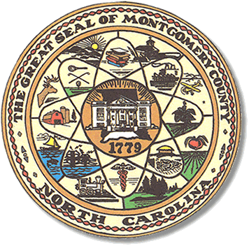

Montgomery County
Board of Elections

Mary Cagle, Chairman
John Adams, Vice Chair
Demond Hairston, Secretary

Dree Wynkoop, Member
Debbie Burris, Member

BOARD MEETING MINUTES

July 9, 2019
5:36 p.m.

The Montgomery County Board of Elections (BOE) met Tuesday, July 9, 2019 at 5:30 p.m. at the BOE Office at 327 Main St in Troy, NC. Present were: Dree Wynkoop, Demond Hairston, Debbie Burris, and Mary Cagle. John Adams called in for the meeting. Also present was the Director of Elections, Rhonda Johnson and Deputy Director Kim Batten.

Mary called the meeting to order at 5:36 p.m.

There were no public comments. With none, the board moved on to next item on agenda.

Dree Wynkoop motioned the June 2019 minutes be approved. Demond Hairston seconded the motion. All approved and the motion carried.

Rhonda Johnson distributed a list of candidates that has filed for office.

Rhonda Johnson advised One Stop Plan for the November Municipal Election is due August 30, 2019. The Board members said they would work on that in the August 20th meeting.

Board members discussed the hours of One Stop voting in small counties versus larger counties. Do all the counties have the same hours and the affect it has on the budget. Rhonda advised that she determines the cost of the election per municipal. She will bill each municipal at the end of the election. The reimbursements go back into the General Fund.

The next board meeting was scheduled for August 13th 2019 but the Board voted and agreed to move the meeting to the 20th of August at 5:30 pm. The Boards reason to move the meeting later is due to having to meet on the 20th to appoint chief judges and judges.

With no further business at hand, Mary Cagle motioned to adjourn the meeting with a second from Wynkoop. All in favor and the meeting adjourn at 6:02p.m.

________________________________________ CHAIRMAN

________________________________________ VICE CHAIR

________________________________________ SECRETARY

________________________________________ MEMBER

________________________________________ MEMBER
Montgomery County Board of Elections

