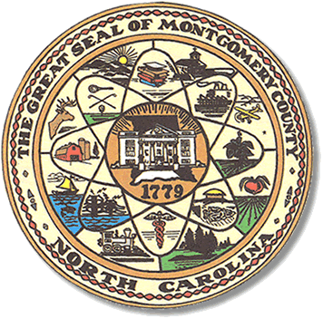

Montgomery County
Board of Elections

Mary Cagle, Chairman
John Adams, Vice Chair
Demond Hairston, Secretary

Dree Wynkoop, Member
Debbie Burris, Member

BOARD MEETING MINUTES

July 21, 2020
5:30 p.m.

The Montgomery County Board of Elections (BOE) meet Tuesday July 21, 2020 at 5:30 p.m. at the BOE Office at 327 Main St in Troy, NC. Present were: Dree Wynkoop, Demond Hairston, Debbie Burris, Mary Cagle and John Adams. Also present was the Director of Elections, Rhonda Johnson, and Deputy Director Kim Batten.

Mary Cagle called the meeting to order at 5:30 p.m.

There were no minutes to approve.

Public comments recognize Shirley Harris and Jennifer Thompson. They are speaking in favor of the 3 one stop sites and additional hours on Saturdays and Sundays during the one stop dates.

This meeting is a continuation of the July 14th meeting to come to an agreement of one stop days and adding additional days. During the last meeting it was agreed there would be 3 locations, Troy, Biscoe, and Mt. Gilead. At the last meeting the Board members could not come to an agreement on one plan.

The board members read the executive order from the executive director of the NC State Board of Elections. The order stated that all NC counties One Stop locations would have to be open each Saturday and Sunday of early voting. The board agreed to first two Saturdays 8 a.m.-1 p.m. The hours for the first two Sundays will be 1 a.m. – 6 p.m.
With the last Saturday 8 a.m.-3 p.m. for early voting in 3 locations.

Rhonda informed the Board of the grant monies that our county will be given.
We will receive $48,497 from the Cares Act grant and $10,000 more in HAVA grant money.

Debbie Burris made a motion to accept these additions days and hours. Mary Cagle seconded the motion, all in favor.

With the end of business, the board moved back to public comments. Jennifer Thompson asked to be recognized. She wanted an explanation of how the Absentees where processed and how the MAT teams were picked. John Adams explained how the absentees were processed. Debbie Burris advised that no names were released until Election Day.

Jennifer Thompson wanted to know how the MAT team was picked. Rhonda Johnson advised she picks the MAT team, one democrat and one republican. John Adams suggested the MAT discussion be table for the next month’s agenda.
Shirley Harris returns to the absentee process. John Adams explained the public can be attended the meeting Election Day when the ballots are called out.

Jennifer Thompson requested a list of all the poll workers.

With no further business at hand, and no other comments. John Adams motioned to adjourn the meeting with a second from Dree Wynkoop. All in favor and the meeting adjourn at 6:10 p.m.

________________________________________ CHAIRMAN

________________________________________ VICE CHAIR

________________________________________ MEMBER

________________________________________ MEMBER

________________________________________ MEMBER
Montgomery County Board of Elections

