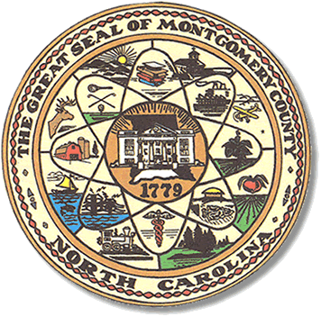

Montgomery County
Board of Elections

Teddi Benson Chairperson
John Adams, Secretary
Debbie Burris, Member

Dree Wynkoop, Member
Tasha Medley, Member

BOARD MEETING MINUTES
July 18, 2023
12:30 p.m.

The Montgomery County Board of Elections (BOE) met July 18, 2023, at
12:30 p.m. at the BOE Office located at 327 N. Main St in Troy, NC.

Present were Tasha Medley, Dree Wynkoop, Debbie Burris, Teddi Benson and John Adams. Also present was the Director of Elections, Rhonda Johnson and Kim Batten, Deputy Director.

As the new Chairperson, Teddi Benson called the meeting to order at 12:31 pm.

The minutes from June 13, 2023, were approved with a motion from John Adams and a second from Dree Wynkoop. All were in favor.

The agenda was approved for the meeting. Dree Wynkoop made the motion to approve the agenda and Tasha Medley seconded the motion. All were in favor.

Rhonda Johnson read the directors report for the board. Rhonda Johnson is still working with HUB to create a video for the state board to show unity and integrity among election workers.

Rhonda Johnson advised we were still waiting on training to be able to produce Voter ID’s.

Rhonda Johnson met with Frankie Maness and some architects to discuss the layout of our new location. Frankie Maness advised that we would be moving to the agriculture building in 2025. He said that he would have maintenance install CO2 and Fire detectors in our current building.

Rhonda stated that we still have not received voter registrations with the new wording advising felons cannot vote.

Rhonda Johnson will have Kenneth Blake take old documents stored in the basement, to the land field.

We will be using the 4-H van for the conference trip in August. We will meet at 3:00 pm Sunday August 13, 2023.

Old Business

The board voted to do away with the Vice Chair position. John Adams was voted in as secretary unanimously.

New Business

The board voted on the 2023 Municipal Election One Stop plan and the vote was unanimous.

The dates for One Stop early voting will be held

Oct. 19-20 8:00 am to 5:00 pm
Oct. 23-27 8:00 am to 5:00 pm
Oct. 30-Nov. 3 8:00 am to 5:00 pm
Nov.4 8:00 am to 3:00pm

November 4th will be the only Saturday and the last day the polls will be open for early voting.

Rhonda Johnson will put this information on the BOE website.

With no further business at hand, and no other comments, Teddi Benson called for a motion to adjourn. Dree Wynkoop moved to adjourn the meeting with a second from Debbie Burris. All were in favor and the meeting was adjourned at 1:00 p.m.

________________________________________ CHAIR

________________________________________ SECRETARY

________________________________________ MEMBER

________________________________________ MEMBER

________________________________________ MEMBER
Montgomery County Board of Elections

