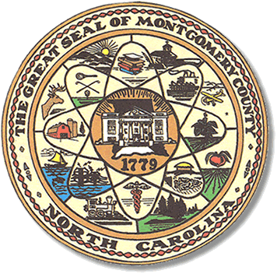

Montgomery County
Board of Elections

Karen Blair, Chairperson
John Adams, Vice Chair
Debbie Burris, Secretary

Dree Wynkoop, Member
Tasha Medley, Member

BOARD MEETING MINUTES
July 12, 2022
5:30 p.m.

The Montgomery County Board of Elections (BOE) met Tuesday, July 12, 2022 at
5:30 p.m. at the BOE Office at 327 Main St in Troy, NC. Present were: Dree Wynkoop, Debbie Burris and Karen Blair. Tasha Medley and John Adams were present via Zoom. Also present were the Director of Elections, Rhonda Johnson and the Deputy Director Kim Batten.

Karen Blair called the meeting to order at 5:30 p.m.

The agenda was approved for the July 12, 2022 meeting. Dree Wynkoop made a motion to approve the agenda and Debbie Burris seconded the motion. All were in favor.

The minutes from 6/14 were approved with a motion from Dree Wykoop and a second by Debbie Burris.

No public comments.

The board discussed the new voting equipment that is coming to the election office. Rhonda explained to the board that she would have software training. The Director and staff will have equipment training. The board members asked if they or the public could attend the equipment training. Rhonda said she would get with the NCSBOE and find out who can be in attendance. Rhonda will email the board members information about the equipment training dates.

Rhonda shared with the board members that the virtual conference on August 30 and 31 of 2022 would be more cost effective if the board and staff all attend. We get a discount for a group rate. Rhonda said she would sign everyone up for the training
And ask that everyone attend.

The board discussed getting future board minutes and agenda emailed earlier in the month prior to the next meeting. This would give the board time to look at the minutes and the topics would be fresh in their memory. It was decided to have the agenda sent out the Thursday prior to the monthly business meeting. The minutes would be sent to board members one week after a business meeting. The board put it to a vote and Tasha Medley made a motion. Dree Wynkoop seconded the motion and all approved.

The board discussed conducting a voter registration drive in September of 2022. They discussed getting with the party chairs to conduct registration drives at the Montgomery Community College and the Montgomery County High School. The talked about having a drive on September 20th since that is National Voter Registration Day. Karen said she would contact the two schools. The party chairs said they would like to participate in voter registration drives.

The board discussed poll worker recruitment. Rhonda told the board they have printed a recruitment pamphlet, from the NCSBOE site, that has an application in it for anyone interested in working the polls. She told the board she would place the pamphlet on the county website. She also said she would put the pamphlets in some public places. They asked that the pamphlet be emailed to them and the party chairs.

With no further business at hand, and no other comments, Debbie Burris moved to adjourn the meeting with a second from Dree Wynkoop. All were in favor and the meeting was adjourned at 6:21 p.m.

________________________________________ CHAIR

________________________________________ VICE CHAIR

________________________________________ MEMBER

________________________________________ MEMBER

________________________________________ MEMBER
Montgomery County Board of Elections

