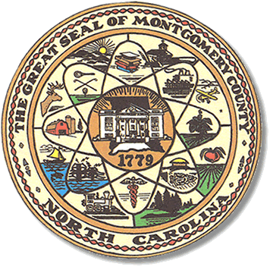

Montgomery County
Board of Elections

Karen Blair, Chairperson
John Adams, Vice Chair
Debbie Burris, Secretary

Dree Wynkoop, Member
Tasha Medley, Member

BOARD MEETING MINUTES
January 18, 2022
5:30 p.m.

The Montgomery County Board of Elections (BOE) met Tuesday, January 18, 2022 at
5:30 p.m. at the BOE Office at 327 Main St in Troy, NC. Present were: John Adams, and Debbie Burris. Dree Wynkoop, Tasha Medley and Karen Blair were available by Zoom. Also present were the Director of Elections, Rhonda Johnson and the Deputy Director Kim Batten.

John Adams called the meeting to order at 5:35 p.m.

The agenda was approved for the January 18, 2022 meeting. Dree Wynkoop made the motion to approve the agenda and Debbie Burris seconded the motion.

The minutes from December 14, 2021 were approved.
Debbie Burris motioned to approve the minutes and Dree Wynkoop seconded the motion.

First item on the agenda is the Hart Demo. Rhonda Johnson told them she had not heard from them but would try contact again.

Secondly, Rhonda Johnson advised the board members that they would need to be thinking about One Stop hours and days. She told them they would have to decide on the days and hours at the February 8th board meeting. John Adams and Karen Blair asked for a list of candidates that has filed for the 2022 Primary, to be emailed to them
And to the party chairs.
Rhonda Johnson distributed the 2022 Board Meeting Calendar for review.

Rhonda Johnson advised the March Conference would be virtual and the conference in August would be in-person.

There were no public comments.

With no further business at hand, and no other comments, John Adams moved to adjourn the meeting with a second from Karen Blair. All were in favor and the meeting was adjourned at 6:08 p.m.

________________________________________ CHAIRPERSON

________________________________________ VICE CHAIR

________________________________________ MEMBER

________________________________________ MEMBER

________________________________________ MEMBER
Montgomery County Board of Elections

