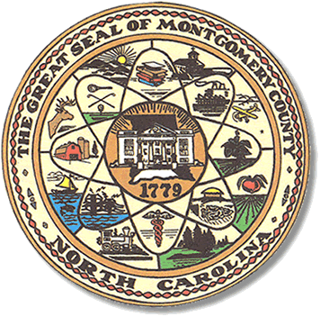

Montgomery County
Board of Elections

Mary Cagle, Chairman
John Adams, Vice Chair
Demond Hairston, Secretary

Dree Wynkoop, Member
Debbie Burris, Member

BOARD MEETING MINUTES

January 14, 2020
5:30 p.m.

The Montgomery County Board of Elections (BOE) met Tuesday January 14, 2020 at 5:30 p.m. at the BOE Office at 327 Main St in Troy, NC. Present were: Dree Wynkoop, Demond Hairston, Debbie Burris, Mary Cagle and John Adams. Also present was the Director of Elections, Rhonda Johnson, and Deputy Director Kim Batten.

John Adams called the meeting to order at 5:30 p.m.

Tom Janyscek with Printelect, Jennifer Thompson, Democratic Party Chair, and C.D. Crepps from Montgomery County Finance Department attended the meeting.

Dree Wynkoop motioned the December 2019 minutes be approved. Mary Cagle seconded the motion. All approved and the motion carried.

Tom Janyscek gave a presentation of the DS 200 Voting Tabulator. He pointed out how easy some features of the DS 200; 3 steps to turn on machine, write–ins will print on the tape, do not have to touch the ballots, and a 4 hour back up battery. He also advised that Printelect would buy back the M 100s. There were other advantages to having updated equipment.

Rhonda Johnson gave the board dates and times for One-Stop and Election Day training. The board agreed they would attend one of the trainings.

Rhonda Johnson gave details for the upcoming conference in Concord NC. Rhonda, Kim and all board members except for Demond Hairston, will attend the conference.

With no further business at hand, Mary Cagle motioned to adjourn the meeting with a second from Dree Wynkoop. All in favor and the meeting adjourned at 6:39p.m.

________________________________________ CHAIRMAN

________________________________________ VICE CHAIR

________________________________________ SECRETARY

________________________________________ MEMBER

________________________________________ MEMBER
Montgomery County Board of Elections

