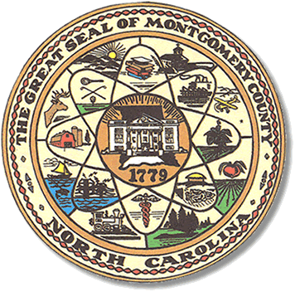

Montgomery County
Board of Elections

Mary Cagle, Chairman
John Adams, Vice Chair
Demond Hairston, Secretary

Dree Wynkoop, Member
Debbie Burris, Member

BOARD MEETING MINUTES
January 13, 2021
5:30 p.m.

The Montgomery County Board of Elections (BOE) met Tuesday, January 13 at 5:30 p.m. at the BOE Office at 327 Main St in Troy, NC. Present were: Dree Wynkoop, Demond Hairston, and Debbie Burris. Also present was the Director of Elections, Rhonda Johnson, and Deputy Director Kim Batten. Mary Cagle was not present.

John Adams motioned to call the meeting to order at 5:30 a.m. Debbie Burris seconded the motion.

Rhonda informed the Board members that Mary Cagle would not be attending due to a sickness.

Demond Hairston motioned to approve the minutes from December. John Adams seconded the motion. All in favor.

Public comments will be held until for the last item on the agenda, Precinct Discussion.

Rhonda Johnson presented the Yearly Resolution for Director. John Adams made the motion to approve and Demond Hairston seconded the resolution. All were in favor and the resolution was signed.

Next on the agenda, Rhonda Johnson provided the 2021 Calendar Meetings to be discussed. In June there will be two meeting dates, regular meeting and announce the new board members. In August there will be two, one regular meeting and one to decide the new poll workers. Rhonda asked if they would like to discuss consolidating the June and August meetings into the usual one meeting per month. The board decided to leave as is for now and review again in May.

The final topic on the agenda is the precinct poll workers. Rhonda Johnson begin by saying thank you to all in attendance. She went on to say there had been some incidents/comments made during Election Day by poll workers. She supplied everyone with a list of those complaints and incidents as told to her. After reviewing and much discussion, the board and party chairs made the following suggestions or comments.

Rhonda Johnson stated that she had an open door policy and that any one of the poll workers could call her any time during the Election Day if something was not right.

John Adams stated it was better to deal directly with the individual. John Adams also stated they would look for things while at the precincts on Election Day.

Dree Wynkoop suggested interviewing each poll worker.

Jennifer Thompson stated that maybe they are not trained properly because the majority of the group was good. In response to Jennifer, John Adams stated that additional training was available to any precinct official during the election.

Deanne Brown stated that consistency is key. Give them the training and material and it is on the official to speak up if they don’t feel confident in what they have learned.
She also suggested that all complaints go to the party chairs.

Others suggestions were made; video’s, mock elections, examples of the material. Both party chairs to attend some of the training and participate as a voter.

Rhonda Johnson stated that all suggestions would be taken into advisement and considered.

At the end of the discussion, John Adams asked Rhonda Johnson to check into the video training from the state. He also suggested training by position. Debbie Burris suggested groups broke into good, medium, and needy. Rhonda stated that she would like to train the officials by groups of new workers and long time workers.

With no further business at hand, John Adams motioned to adjourn the meeting with a second from Dree Wynkoop. All in favor. The board adjourned at 6:39 p.m.

________________________________________ CHAIRMAN

________________________________________ VICE CHAIR

________________________________________ SECRETARY

________________________________________ MEMBER

________________________________________ MEMBER
Montgomery County Board of Elections

