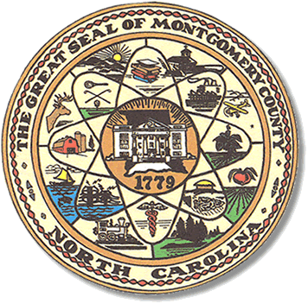

Montgomery County
Board of Elections

Karen Blair, Chairperson
John Adams, Vice Chair
Debbie Burris, Secretary

Dree Wynkoop, Member
Tasha Medley, Member

BOARD MEETING MINUTES
February 8, 2022
5:30 p.m.

The Montgomery County Board of Elections (BOE) met Tuesday, February 8, 2022 at
5:30 p.m. at the BOE Office at 327 Main St in Troy, NC. Present were: John Adams, Debbie Burris and Dree Wynkoop. Tasha Medley and Karen Blair were available by Zoom. Also present were the Director of Elections, Rhonda Johnson and the Deputy Director Kim Batten.

John Adams called the meeting to order at 5:30 p.m.

The agenda was approved for the February 8, 2022 meeting. Dree Wynkoop made the motion to approve the agenda and Debbie Burris seconded the motion.

The minutes from January 18, 2021 were approved.
John Adams motioned to approve the minutes and Dree Wynkoop seconded the motion.

The board decided there would be three One Stop locations, Troy, Mt. Gilead, and Biscoe. The hours for each locations will be 8:00 a. m. – 7:30 p.m., Monday – Friday with the last Saturday before the election 8 a.m. – 3:00 p.m.
John moved to accept these hours and locations with a second from Dree Wynkoop.

Rhonda Johnson reminded the board that the Eldorado precinct is a temporary location
Again this year. The NCSBOE has agreed to let us use the Eldorado Community Bldg.
For the Uwharrie voters temporarily. There has been discussion in the past for a new location with no resolution. The board will continue to find a solution to the Uwharrie precinct situation.

There were no public comments.

With no further business at hand, and no other comments, John Adams moved to adjourn the meeting with a second from Karen Blair. All were in favor and the meeting was adjourned at 6:08 p.m.

________________________________________ CHAIRPERSON

________________________________________ VICE CHAIR

________________________________________ MEMBER

________________________________________ MEMBER

________________________________________ MEMBER
Montgomery County Board of Elections

