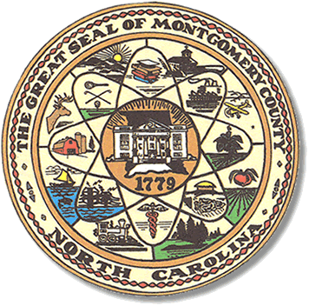

Montgomery County
Board of Elections

Mary Cagle, Chairman
John Adams, Vice Chair
Demond Hairston, Secretary

Dree Wynkoop, Member
Debbie Burris, Member

BOARD MEETING MINUTES
February 9, 2021
5:30 p.m.

The Montgomery County Board of Elections (BOE) met Tuesday, January 13 at 5:30 p.m. at the BOE Office at 327 Main St in Troy, NC. Present were: Dree Wynkoop, John Adams, and Debbie Burris. Demond Hairston and Mary Cagle were present by phone. Also present was the Director of Elections, Rhonda Johnson, and Deputy Director Kim Batten.

John Adams motioned to call the meeting to order at 5:30 a.m. Debbie Burris seconded the motion.

Dree Wynkoop motioned to approve the minutes and Debbie Burris seconded the motion. All in favor.

Rhonda Johnson started the meeting by saying the county would be receiving HAVA funds. Originally, the grant was for $10,000 but it has been increased to $35,000. Rhonda Johnson advised the board with the increase we would now have enough money to purchase all new laptops. The board put this suggestion to motion and all were in favor.

With the next election, which is the Municipal in the fall, Rhonda Johnson advised the board there will be no grant money to pay for the Safety and Greeter person. The cost for that is $14,000 which the county will cover. John Adams stated we should get that cost in writing.

Rhonda Johnson stated to the board she had secured some like new voting booths, and voting signage from Cabarrus County. There are about 20 booths and several boxes of
Vote here and other precinct signs.

With no further business at hand, John Adams motioned to adjourn the meeting with a second from Debbie Burris. All in favor. The board adjourned at 5:43 p.m.

________________________________________ CHAIRMAN

________________________________________ VICE CHAIR

________________________________________ SECRETARY

________________________________________ MEMBER

________________________________________ MEMBER
Montgomery County Board of Elections

