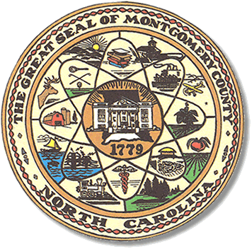

Montgomery County
Board of Elections

Mary Cagle, Chairman
John Adams, Vice Chair
Demond Hairston, Secretary

Dree Wynkoop, Member
Debbie Burris, Member

BOARD MEETING MINUTES

February 25, 2020
5:00 p.m.

The Montgomery County Board of Elections (BOE) met Tuesday February 18, 2020 at 5:00 p.m. at the BOE Office at 327 Main St in Troy, NC. Present were: Dree Wynkoop, Demond Hairston, Debbie Burris, Mary Cagle and John Adams. Also present was the Director of Elections, Rhonda Johnson, and Deputy Director Kim Batten.

John Adams called the meeting to order at 5:04 p.m.

There were no public comments.

Dree Wynkoop motioned the February 18th minutes be approved. Mary Cagle seconded the motion. All approved and the motion carried.

There were 24 absentee ballots to be reviewed and approved. Military and overseas ballots that were emailed to our office were duplicated onto an actual ballot.
Dree Wynkoop and Debbie Burris marked half and John Adams and Mary Cagle marked the other half. Once all ballots were approved Dree Wynkoop and Rhonda Johnson fed the ballots into the M100. There were 18 Civilian and 6 Military.
John Adams made motion to approve all 24 ballots and Demond Hairston seconded the motion.

With no further business at hand, Mary Cagle motioned to adjourn the meeting with a second from John Adams. All in favor and the meeting adjourned at 5:55p.m.

________________________________________ CHAIRMAN

________________________________________ VICE CHAIR

________________________________________ SECRETARY

________________________________________ MEMBER

________________________________________ MEMBER
Montgomery County Board of Elections

