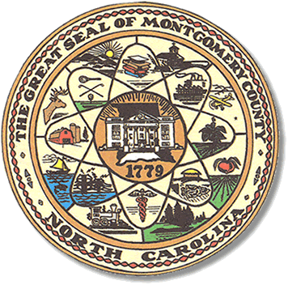

Montgomery County
Board of Elections

Mary Cagle, Chairman
John Adams, Vice Chair
Demond Hairston, Secretary

Dree Wynkoop, Member
Curtis Carter, Member

BOARD MEETING MINUTES

February 25, 2019
9:00

The Montgomery County Board of Elections (BOE) met Tuesday, February 25, 2019 at 9:00 a.m. in the BOE Office at 327 Main St in Troy, NC. Present were: Mary Cagle, John Adams, Curtis Carter, Dree Wynkoop, and Demond Hairston. Also present was the Director of Elections, Rhonda Johnson and Deputy Director Kim Batten.

The board was sworn in by John Deaton, the Clerk of Court for Montgomery County. This now includes a fifth board member, Demond Hairston.

The board organized with Mary Cagle as Board Chairman, John Adams Vice Chairman, Demond Hairston Secretary, Curtis Carter, member and Dree Wynkoop, member.

Mary called the meeting to order at 9:11 a.m. with a second by John Adams. The motion carried.

Board Chairman, Mary Cagle, called for any public comment. With none, the board moved on to next item on agenda.

Minutes from the December meeting were not available. Those minutes will be read at the next meeting in March 2019.

Calendar of meeting dates was distributed to all the Board members.

Rhonda Johnson advised municipals in fall 2019 would be held in Biscoe, Mt. Gilead, and Candor. John Adams wanted to discuss Early Voting at a later meeting.

Rhonda Johnson stated the North Carolina Association of Directors of Elections will hold their conference Mar. 30 – Apr. 2. The board members, with exception of Dree Wynkoop, will attend the conference along with Director Rhonda Johnson and Deputy Director, Kim Batten.

With no further business at hand, Curt Carter made a motion to adjourn the meeting with a second from Dree Wynkoop. All are in favor and the meeting was adjourned at 9:32 a.m.

________________________________________ CHAIRMAN

________________________________________ VICE CHAIR
________________________________________ SECRETARY

________________________________________ MEMBER

________________________________________ MEMBER
Montgomery County Board of Elections

