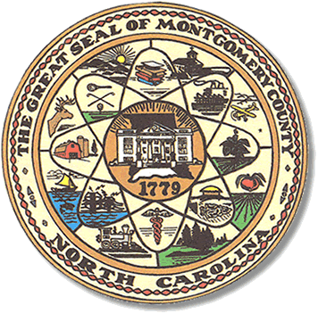

Montgomery County
Board of Elections

Mary Cagle, Chairman
John Adams, Vice Chair
Demond Hairston, Secretary

Dree Wynkoop, Member
Debbie Burris, Member

BOARD MEETING MINUTES

February 18, 2020
5:00 p.m.

The Montgomery County Board of Elections (BOE) met Tuesday January 14, 2020 at 5:30 p.m. at the BOE Office at 327 Main St in Troy, NC. Present were: Dree Wynkoop, Demond Hairston, Debbie Burris, Mary Cagle and John Adams. Also present was the Director of Elections, Rhonda Johnson, and Deputy Director Kim Batten.

Mary Cagle called the meeting to order at 5:04 p.m.

There were no public comments.

Dree Wynkoop motioned the January minutes be approved. Mary Cagle seconded the motion. All approved and the motion carried.

There were a total of 5 absentees. 1 military, 2 civilian, and 2 overseas. The board looked at and approved all 5 absentee ballots. The board agreed to wait until the next board meeting to duplicate the emailed military and overseas ballots. The board also agreed in an earlier resolution they adopted, to put all absentee ballots thru an M100 tabulator, in order to save time on Election Day. The M100 will not be closed and a total tape will not be read until Election Day. John Adams made the motion to approve these 5 absentees and Dree Wynkoop seconded the motion.

With no further business at hand, John Adams motioned to adjourn the meeting with a second from Mary Cagle. All in favor and the meeting adjourned at 5:39p.m.

________________________________________ CHAIRMAN

________________________________________ VICE CHAIR

________________________________________ SECRETARY

________________________________________ MEMBER

________________________________________ MEMBER
Montgomery County Board of Elections

