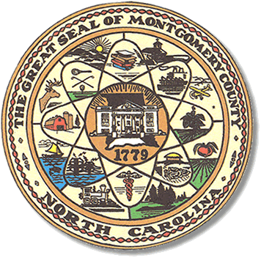

Montgomery County
Board of Elections

Karen Blair, Chairperson
John Adams, Vice Chair
Debbie Burris, Secretary

Dree Wynkoop, Member
Tasha Medley, Member

BOARD MEETING MINUTES
December 13, 2022
5:30 p.m.

The Montgomery County Board of Elections (BOE) met December 13, 2022 at
5:30 p.m. at the BOE Office at 327 Main St in Troy, NC. Present were: Dree Wynkoop, Debbie Burris, Karen Blair and John Adams. Also present was the Director of Elections, Rhonda Johnson. Tasha Medley was not present.

Karen Blair asked the meeting to be called to order. John Adams gave the motion with a second from Debbie Burris.

The agenda was approved for meeting. John Adams made the motion to approve the agenda and Dree Wynkoop seconded the motion. All were in favor.

There were no minutes to approve for this meeting.

There were no public comments.

Old Business
None

New Business
Karen Blair declared that on Election Day she visited 12 out of 14 precincts.

John Adams stated that he talked to the chief judges at the locations he had visited. John Adams stated one of the issues he found was Little River precinct had a “Do Not Touch” sign on the screen of the DS 200 (tabulator). He suggested they put it in a different place.

John Adams suggested not using the Mt. Gilead Fire Department on Election Day instead make Highlands Community Center the precinct for One-Stop and Election Day. Everyone thought it was a good idea. John Adams moved to motion and Dree Wynkoop seconded the motion. All were in favor. Rhonda Johnson will advise the public when approved by the state board.

Another issue from John Adams was at the Cheeks Creek precinct. They received a computer that was not theirs. John Adams suggested there be a checklist for the Chief Judge when they pick up their supplies on the day before the election. He was reminded there already is a checklist that is being used.

John Adams suggested we might get some young people from Outreach Programs.
Dree Wynkoop suggested we start with the young people that are registered to vote. These comments were all from his visits to precincts on Election Day.

Karen Blair wanted to know about the incident with the voter putting the provisional in the DS 200 and how it was retrieved. Rhonda Johnson explained how the provisional is supposed to be handle and that there should be a “P” written at the top of the ballot so the chief judge can retrieve ballot.

Many suggestions were discussed to help improve poll workers job. Using a stamp with a P on provisional ballots. Poll workers to wear name tags. The board was reminded that the poll workers have name badges with party and precinct on them already. It was suggested that have the poll workers from each precinct sit together during training.

There was much discussion about selection of poll workers and poll workers not working in their precinct. Rhonda Johnson would like to have an alternate for each precinct and a list of alternates for those who drop out closer to the Election Day when the poll worker list is submitted to her. Board members would like to be notified (email) every day the poll worker list changes.

With no further business at hand, and no other comments, Karen Blair called for motion to adjourn. Dree Wynkoop moved to adjourn the meeting with a second from Debbie Burris. All were in favor and the meeting was adjourned at 6:52 p.m.

________________________________________ CHAIR

________________________________________ VICE CHAIR

________________________________________ MEMBER

________________________________________ MEMBER

________________________________________ MEMBER
Montgomery County Board of Elections

