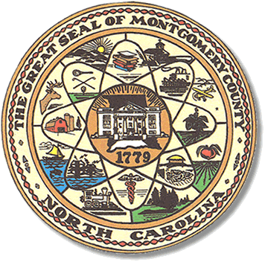

Montgomery County
Board of Elections

Mary Cagle, Chairman
John Adams, Vice Chair
Demond Hairston, Secretary

Dree Wynkoop, Member
Debbie Burris, Member

BOARD MEETING MINUTES

DECEMBER 10, 2019
5:00 p.m.

The Montgomery County Board of Elections (BOE) meet Tuesday December 10, 2019 at 5:00 p.m. at the BOE Office at 327 Main St in Troy, NC. Present were: Dree Wynkoop, Demond Hairston, Debbie Burris, Mary Cagle and John Adams. Also present was the Director of Elections, Rhonda Johnson, and Deputy Director Kim Batten.

John Adams called the meeting to order at 5:34 p.m.

Sam Martin and Shirley Harris attended the meeting.
Sam and Shirley explained they were here to help find Democrat poll workers due to the party not being able to provide a list prior to the regular 2019 August precinct official appointment meeting. Martin and Harris both spoke of poll workers being out of precinct. Shirley Harris explain they were here to help find and place poll workers in correct precincts.

Rhonda Johnson explained to Shirley Harris and Sam Martin that not all people appointed on the list are willing to work, then the election staff has to try and find someone to work.

Shirley Harris stated again that she and Sam Martin were here to help and they would find people to work and present them at our January meeting.

On that note, the Board moved on to the next item on the agenda.

The board decides to have three One Stop locations: Biscoe at the Town Hall, Troy at the library. For Mt. Gilead, Rhonda had concerns about returning to last one stop location which was the Highland Community center and wanted to use the Leah Levin Auditorium. John Adams wanted Rhonda Johnson to confirm the Leah Levin Auditorium before they signed the One Stop plan. The board agreed on three locations.

With no further business at hand, John Adams motioned to adjourn the meeting with a second from Dree Wynkoop. All in favor and the meeting adjourn at 6:45 p.m.

________________________________________ CHAIRMAN

________________________________________ VICE CHAIR

________________________________________ SECRETARY

________________________________________ MEMBER

________________________________________ MEMBER
Montgomery County Board of Elections

