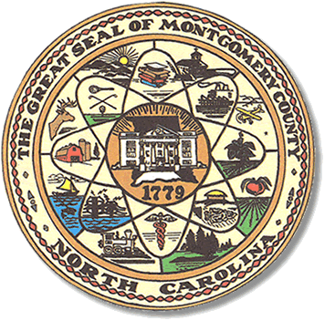

Montgomery County
Board of Elections

Mary Cagle, Chairman
John Adams, Vice Chair
Demond Hairston, Secretary

Dree Wynkoop, Member
Debbie Burris, Member

BOARD MEETING MINUTES

December 10, 2020
10:00 a.m.

The Montgomery County Board of Elections (BOE) met Thursday December 10, 2020 at 10:00 a.m. at the BOE Office at 327 Main St in Troy, NC. Present were: Dree Wynkoop, Demond Hairston, Mary Cagle and Debbie Burris. Also present was the Director of Elections, Rhonda Johnson, and Deputy Director Kim Batten.

Demond Hairston motioned to call the meeting to order at 10:09 a.m. Debbie Burris seconded the motion.

Demond Hairston motioned to approve the minutes from November. Dree Wynkoop seconded the motion. All in favor.

Rhonda Johnson started the meeting by stating the N.C. court of appeals will hear the Newby/Beasley protest.

Rhonda Johnson also advised the board would receive their bonuses the following week.

Rhonda Johnson reminded the board that we must find a new precinct for Uwharrie for the Election in 2022. One suggestion is Donnie Mullinix old store place. Rhonda asked the board members to be thinking about it. We do have a little while to work on this.

Rhonda Johnson advised the board that we needed to discuss the poll workers with party chairs. The board stated that open comments would need to be approved by the board and the board will set a time limit for discussion.

There were no public comments.

With no further business at hand, Dree Wynkoop motioned to adjourn the meeting with a second from Debbie Burris. All in favor. The board adjourned at 10:50 a.m.

________________________________________ CHAIRMAN

________________________________________ VICE CHAIR

________________________________________ SECRETARY

________________________________________ MEMBER

________________________________________ MEMBER
Montgomery County Board of Elections

