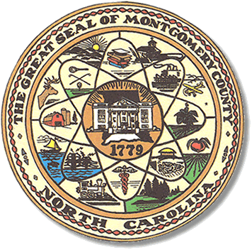

Montgomery County
Board of Elections

Teddi Benson Chairperson
John Adams, Secretary
Debbie Burris, Member

Dree Wynkoop, Member
Tasha Medley, Member

BOARD MEETING MINUTES
Aug 22, 2023
5:30p.m.

The Montgomery County Board of Elections (BOE) met August 22, 2023, at
5:30 p.m. at the BOE Office located at 327 N. Main St in Troy, NC. Present were Dree Wynkoop, Debbie Burris, Teddi Benson and John Adams. Tasha Medley was not present. Also present was Kim Batten, Deputy Director. Rhonda Johnson was on vacation.

Teddi Benson, chairperson called the meeting to order at 5:30 pm.

The minutes from July 18, 2023, were approved with a motion from Dree Wynkoop and a second from Debbie Burris. All were in favor.

The agenda was approved for the meeting. John Adams made the motion to approve the agenda and Dree Wynkoop seconded the motion. All were in favor.

Old Business

There is no old business.

New Business

Board members were given a list of the 2023-2025 potential precinct officials from both parties. They approved most precinct officials but there were a few that the board did not approve. Party chairs were present for the meeting to discuss any changes made by the board.

(Copy of final list attached.)

With no further business at hand, and no other comments, Teddi Benson called for a motion to adjourn. Dree Wynkoop moved to adjourn the meeting with a second from Debbie Burris. All were in favor and the meeting was adjourned at 6:13 p.m.

________________________________________ CHAIR

________________________________________ SECRETARY

________________________________________ MEMBER

________________________________________ MEMBER

________________________________________ MEMBER
Montgomery County Board of Elections

