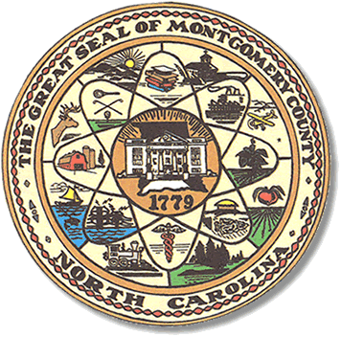

Montgomery County
Board of Elections

Mary Cagle, Chairman
John Adams, Vice Chair
Demond Hairston, Secretary

Dree Wynkoop, Member
Curtis Carter, Member

BOARD MEETING MINUTES

April 14, 2019
5:30 p.m.

The Montgomery County Board of Elections (BOE) met Tuesday, April 14, 2019 at 5:30 p.m. at the BOE Office at 327 Main St in Troy, NC. Present were: John Adams, Dree Wynkoop, Demond Hairston and Mary Cagle. Also present was the Director of Elections, Rhonda Johnson and Deputy Director Kim Batten.

Mary Cagle called the meeting to order at 5:38 p.m.

There was no public comment. With none, the board moved on to next item on agenda.

John Adams motioned the March 2019 minutes be approved. Demond Hairston seconded the motion. The motion carried.

Rhonda Johnson gave the board a memo concerning the Absentee Application and Certificate Form absentee witness certification and absentee ballot form. The form will now ask each witness to provide the date on which he or she signed the witnesses’ certification field. The State Board wants to remind all counties that, under current law, county boards cannot require the date or discount a ballot merely due to a date discrepancy.

Demond Hairston, Mary Cagle, Rhonda Johnson and Kim Batten attended the March 2019 conference in Hickory. Rhonda Johnson updated the other board members with news from the conference. The U.S. Govt. gave NC about the $380,000,000 for election supplies. This money will be used for whatever the NC State decides, not the counties. As of the conference date, the state of NC had not issued any funding to any counties. There are currently bills in the NC House and Senate to shorten One Stop Voting and to get rid of 2nd primaries.

Curtis Carter resigned his seat on County Board of Elections due to his work schedule.

With no further business at hand, John Adams made a motion to adjourn the meeting with a second from Mary Cagle. All are in favor and the meeting was adjourned at 6:06 p.m.

________________________________________ CHAIRMAN

________________________________________ VICE CHAIR

________________________________________ SECRETARY

________________________________________ MEMBER

________________________________________ MEMBER
Montgomery County Board of Elections

