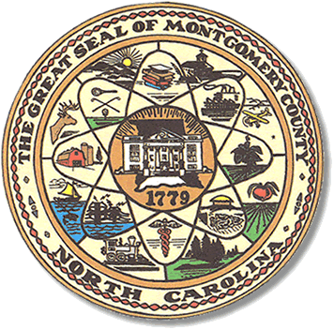

Montgomery County
Board of Elections

Mary Cagle, Chairman
John Adams, Vice Chair

Dree Wynkoop, Member
Curtis Carter, Member

BOARD MEETING MINUTES

August 14, 2018
5:30 PM

The Montgomery County Board of Elections (BOE) met Tuesday, August 14 at 5:30 p.m. in the BOE Office, Room 101 in the Montgomery County Courthouse. Present were Board members: John Adams, Dree Wynkoop, and Curtis Carter. Also present was the Director of Elections, Rhonda Iacona and Deputy Director Kim Batten.

John Adams called meeting to order at 5:35.

Dree Wynkoop made a motion to accept minutes from July 17, 2018. Curt Carter seconded the motion. All are in favor.

Sam Martin, the Democrat Party Chairman, was present for public comments. He asked the board members and Director if candidates were given information on placing of signs, at the time of their filing. He said that some candidates were not following the statute and placing signs out early. He presented ordinance 136-32 which states campaign signs should be displayed 30 days prior to the start of One-Stop voting.

Rhonda Iacona stated that the Board of Elections had never enforced the statutes regarding time placement of signs. John Adams stated that we were not here to police the signs. The Board decided to draft a letter and send out to all candidates as a reminder of when the signs should go out and when they should be picked up. The letter was sent out the next day.

Rhonda Iacona gave the Board a copy of the One Stop Plan approved by the State Board.

John Adams wanted a One Stop list of workers along with an updated list of who has agreed to work the Polls.

Rhonda stated training for One Stop workers will be in October.

Wadeville Fire Tax will be on the ballot.

Security was discussed and John Adams suggested drafting a letter to the Sheriff and to the county manager, requesting they put a computer outside the election office for the Deputy’s to use for clocking in and out. It was discussed that no one should be coming into the election office using the computers. It was also discussed that the locks on the doors to the Election office need to be changed.

Dree Wynkoop made a motion to adjourn the meeting with a second from Curt Carter. All are in favor and the meeting was adjourned at 6:17.

Next meeting of the Board of Elections will be on Tuesday, October 16, 2018 @ 5:00pm.

_______________________________________ CHAIRMAN

________________________________________ VICE CHAIR

________________________________________ MEMBER

________________________________________ MEMBER
Montgomery County Board of Elections

