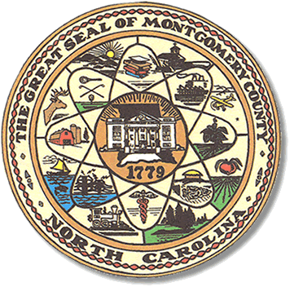

Montgomery County
Board of Elections

Mary Cagle, Chairman
John Adams, Vice Chair

Dree Wynkoop, Member
Curtis Carter, Member

BOARD MEETING MINUTES

July 17, 2018
5:30 PM

The Montgomery County Board of Elections (BOE) met Tuesday, June 7, 2018 at 5:30 p.m. in the BOE Office, Room 101 in the Montgomery County Courthouse. Present were Board members: Mary Cagle, John Adams, Dree Wynkoop, and Curtis Carter. Also present was the Director of Elections, Rhonda Iacona and Deputy Director Kim Batten.

Mary Cagle called meeting to order at 5:30.

The Board members reorganized. Dree Wynkoop nominated John Adams for Chairman of the board. Mary Cagle made the motion to accept John Adams as chairman and Curt Carter made the second motion. All are in favor.
John Adams made a motion to accept Mary Cagle for Vice Chairman.
Curt Carter made second motion. All are in favor.

John Adams made a motion to accept the minutes from May 8, 2018 and June 7, 2018. Curt seconded the motion. All are in favor.

Sam Martin, the Democrat Party Chairman was present for public comments. Mr. Martin expressed that on behalf of the Democrats, they appreciate all we do.

The Board discussed contacting the originally appointed Precinct officials to confirm they will work the Polls in the November 6, 2018 General Election. John Adams suggested the precinct officials be contacted earlier in the year, to avoid last minute issues with poll workers.

Rhonda Iacona informed the Board that Montgomery County now shares their judicial district with Stanly County. We are now district 20A for all judicial seats.

The Board discussed the new mandate passed by the State that all One Stop/ Early Voting locations open from 7 a.m. – 7 p.m. during week days.
The Board decided our One Stop Plan would be the following; two locations, Troy public Library and the Biscoe Town Hall, operating from October 17th thru November 2nd, 7a.m. – 7p.m.weekdays. There will be only one Saturday, November 3rd operating from 8 a.m. – 5 p.m. at both locations.
Mary Cagle made the motion to accept Troy and Biscoe for our One Stop locations and Dree Wynkoop seconded the motion.

Rhonda Iacona typed the resolution for One Stop for the Board to sign.

Curt Carter wanted to reserve the right to change his opinion on One Stop location and hours in future elections.

Curt Carter made a motion to adjourn the meeting with a second from Dree Wynkoop. All are in favor and the meeting was adjourned at 6:34.

Next meeting of the Board of Elections will be on Tuesday, August 14, 2018 @ 5:30pm.

_______________________________________ CHAIRMAN

________________________________________ VICE CHAIR

________________________________________ MEMBER

________________________________________ MEMBER
Montgomery County Board of Elections

