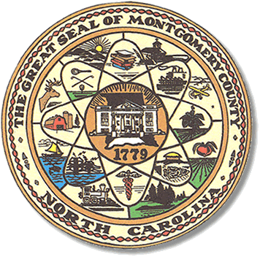

Montgomery County
Board of Elections

Karen Blair, Chairperson
John Adams, Vice Chair
Debbie Burris, Secretary

Dree Wynkoop, Member
Tasha Medley, Member

BOARD MEETING MINUTES
June 14, 2022
5:30 p.m.

The Montgomery County Board of Elections (BOE) met Tuesday, June 14, 2022 at
5:30 p.m. at the BOE Office at 327 Main St in Troy, NC. Present were: Dree Wynkoop, Debbie Burris, Tasha Medley, Karen Blair and John Adams. Also present were the Director of Elections, Rhonda Johnson and the Deputy Director Kim Batten.

Karen Blair called the meeting to order at 5:32 p.m.

The agenda was approved for the June 14, 2022 meeting. John Adams made a motion to approve the agenda and Debbie Burris seconded the motion. All were in favor.

The minutes from 5/17 were approved with a motion from Dree Wykoop and a second by Debbie Burris.

No public comments.

Rhonda Johnson and Karen Blair will meet with the County Manager and Commissioners on June 16, 2022 at 6:00 pm to discuss the new election equipment.

The board discussed the poll workers and issues that arose during the last election.
They heard comments from Deanne and Kelsey Brown concerning the conduct of poll workers. Deanne reminded the board members that she removed two poll workers due to misconduct at the precinct.

It was decided that after the election, there will be a debriefing of the election, what went good and what went wrong. How the poll workers handled situations. This will help decide where we need to focus our attention. With a motion from Dree Wynkoop and a second from Tasha Medley, all were in favor. Going forward the first business meeting after each election canvass will be our debriefing meeting.

With no further business at hand, and no other comments, John Adams moved to adjourn the meeting with a second from Dree Wynkoop. All were in favor and the meeting was adjourned at 6:23 p.m.

________________________________________ CHAIR

________________________________________ VICE CHAIR

________________________________________ MEMBER

________________________________________ MEMBER

________________________________________ MEMBER
Montgomery County Board of Elections

