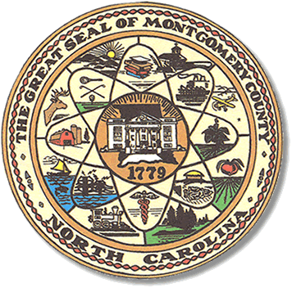

Montgomery County
Board of Elections

Mary Cagle, Chairman
John Adams, Vice Chair
Demond Hairston, Secretary

Dree Wynkoop, Member
Debbie Burris, Member

BOARD MEETING MINUTES

June 9, 2020
5:30 p.m.

The Montgomery County Board of Elections (BOE) meet Tuesday May 12, 2020 at 5:30 p.m. at the BOE Office at 327 Main St in Troy, NC. Present were: Dree Wynkoop, Demond Hairston, Debbie Burris, Mary Cagle and John Adams. Also present was the Director of Elections, Rhonda Johnson, and Deputy Director Kim Batten.

Mary Cagle called the meeting to order at 5:30 p.m.

John Adams made a motion to approve the minutes and Mary Cagle seconded the motion. All in favor.

There was no public comment to be heard.

Rhonda Johnson advised the board that we had mailed letters to the precinct workers from the March 2020 election and asked them if they would work in light of the Corona virus. Rhonda informed the board that we had received 16 favorable responses from poll workers that are willing to work the November 3rd election so far.

So far we have had only one person, Charles Lucas, to file for the Soil & Water office.

Rhonda Johnson advised the board we would have a Corona slide show for training Poll Workers how to clean after each voter. There will be one person assigned to that position. This person will be responsible for getting up pens left behind from voters, sanitized each voting booth, keeping the 6^{ft} distance between voters and other duties that will be shown in training.

The state has assigned a Security and Support Technician to each district. Our support person is Parker Holland. He will be support for IT and “anything” questions.

Due to the virtual conference being charged for, no one in our office will be attending the training conference in August, physically or virtually as of current date.

With no further business at hand, John Adams motioned to adjourn the meeting with a second from Dree Wynkoop. All in favor and the meeting adjourn at 5:40 p.m.

________________________________________ CHAIRMAN

________________________________________ VICE CHAIR

________________________________________ SECRETARY

________________________________________ MEMBER

________________________________________ MEMBER
Montgomery County Board of Elections

