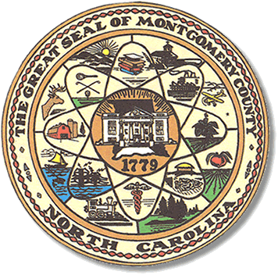

Montgomery County
Board of Elections

Mary Cagle, Chairman
John Adams, Vice Chair

Dree Wynkoop, Member
Curtis Carter, Member

BOARD MEETING MINUTES

June 7, 2018
5:30 PM

The Montgomery County Board of Elections (BOE) met Tuesday, June 7, 2018 at 5:30 p.m. in the BOE Office, Room 101 in the Montgomery County Courthouse. Present were Board members: Mary Cagle, John Adams, Dree Wynkoop, and Curtis Carter. Also present was the Director of Elections, Rhonda Iacona and Deputy Director Kim Batten.

Mary called meeting to order at 5:05.

No public comment.

Due to the election, there were 3 meetings with minutes to be accepted. John made a motion to except minutes from May 14th and May 18th, with a small correction on May 8th minutes.

Budget for 7/1/2018 – 6/30/2018 was reviewed and approved with correction to the totals, line 17.

The Board members resigned the 2018 Primary Election abstract.

Next meeting of the Board of Elections will be on Tuesday, July 10, 2018 @ 5:30pm.

With no other business, Curt made motion to adjourn. John seconded the motion. All in favor. Meeting was adjourned at 6:14.

_______________________________________ CHAIRMAN

________________________________________ VICE CHAIR

________________________________________ MEMBER

________________________________________ MEMBER
Montgomery County Board of Elections

