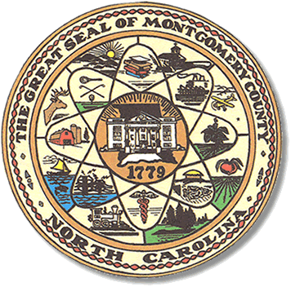

Montgomery County
Board of Elections

Mary Cagle, Chairman
John Adams, Vice Chair

Dree Wynkoop, Member
Curtis Carter, Member

BOARD MEETING MINUTES

MAY 8, 2018
10:00 PM

The Montgomery County Board of Elections (BOE) met Monday, May 8, 2018 at 5:00 p.m. in the BOE Office, Room 101 in the Montgomery County Courthouse. Present were Board members: Mary Cagle, John Adams, Dree Wynkoop, and Curtis Carter. Also present was the Director of Elections, Rhonda Iacona and Deputy Director Kim Batten.

Mary called meeting to order at 10:17 a.m.

Minutes from May 8, 2018 are held over to June 12, 2018.

No public comments.

This purpose of this meeting is to conduct the Hand Eye Audit.
Biscoe One Stop and Ophir Precinct were audited. Audit committee consists of Andrea Marshall, Kim Walter, Carolyn Maness, and Sue McCaskill.

The NCSBOE directed the BOE staff to audit the ballot most used in the May Election and to choose the first contest on that ballot. The most used ballot in our county was the Democrat ballot and Scott Huffman was the first contest on the ballot. The Hand Eye Audit matched the M100 tabulator tapes.

With no other business, Curt made motion to adjourn. Mary seconded the motion and meeting was adjourned at 10:36 a.m. All was in favor.

_______________________________________ CHAIRMAN

________________________________________ VICE CHAIR

________________________________________ MEMBER

________________________________________ MEMBER
Montgomery County Board of Elections

