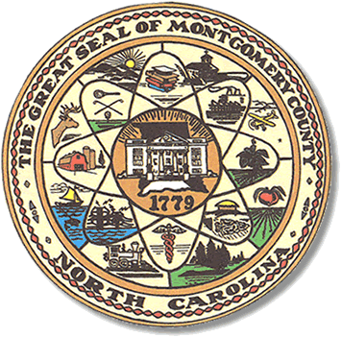

Montgomery County
Board of Elections

Mary Cagle, Chairman
John Adams, Vice Chair

Dree Wynkoop, Member
Curtis Carter, Member

BOARD MEETING MINUTES

MAY 8, 2018
5:00 PM

The Montgomery County Board of Elections (BOE) met Monday, May 8, 2018 at 5:00 p.m. in the BOE Office, Room 101 in the Montgomery County Courthouse. Present were Board members: Mary Cagle, John Adams, Dree Wynkoop, and Curtis Carter. Also present was the Director of Elections, Rhonda Iacona and Deputy Director Kim Batten.

Mary called meeting to order at 5:05.

No minutes to accept.

No public comments.

The Board met to conduct the Pre-Election Absentee Meeting.
The board reviewed 18 absentee ballots. There were 16 approved and 2 oversees for no signature or no date. The voters have been contacted and ballots corrected.

The 16 approved were opened by the Board members.
Mary – called out from the list. John – called from the envelope.
Curt – opened the ballot. Dree – ballot passed to Dree and put faced down.

The Director of Elections placed the Absentee ballots into the M100 tabulator to get a total. Later the Director ran the One Stop Biscoe and Troy tapes to get the totals for the One Stop Voting.

With no other business, Curt made motion to adjourn at. Dree seconded the motion and meeting was adjourned at 6:33 p.m. All was in favor.

_______________________________________ CHAIRMAN

________________________________________ VICE CHAIR

________________________________________ MEMBER

________________________________________ MEMBER
Montgomery County Board of Elections

