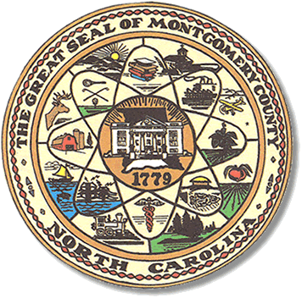

Montgomery County
Board of Elections

Mary Cagle, Chairman
John Adams, Vice Chair

Dree Wynkoop, Member
Curtis Carter, Member

BOARD MEETING MINUTES

MAY 7, 2018
5:00 PM

The Montgomery County Board of Elections (BOE) met Monday, May 7, 2018 at 5:00 p.m. in the BOE Office, Room 101 in the Montgomery County Courthouse. Present were Board members: Mary Cagle, John Adams, Dree Wynkoop, Curtis Carter. Also present was the Director of Elections, Rhonda Iacona and Deputy Director Kim Batten.

The meeting was called to order at 5:04.

John made a motion to accept the minutes from May 7, 2018. Mary seconded the motion. All was in favor.

The board approved 13 absentee ballots rejected 4 for no signature or no date. The voters have been contacted

Rhonda advised the board of an issue in Ophir. A few voters went to vote at One Stop and were told the system said no ballot. Rhonda checked with the North Carolina State Board of Elections and found out that in the Geo Code System, two homes on Substation Road had voters with the correct precinct but the incorrect Voting Tabulation District. The NCSBOE said the Geo Codes could not be opened this close to the Election. The voters would have to vote a provisional and the provisionals would count.

Curt would like any issues that come up during a primary to be emailed to the board prior to the meeting.

John requested the One Stop counts during the meeting.
Troy – 469
Biscoe – 177

With no further business, Mary made a motion to adjourn, Dree made a second motion and the meeting adjourned at 5:37 P.M.

_______________________________________ CHAIRMAN

________________________________________ VICE CHAIR

________________________________________ MEMBER

________________________________________ MEMBER
Montgomery County Board of Elections

