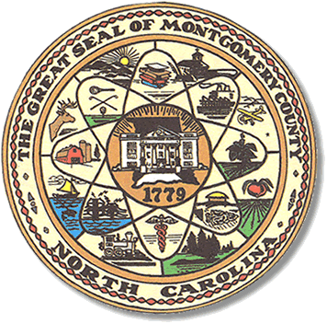

Montgomery County
Board of Elections

Mary Cagle, Chairman
John Adams, Vice Chair

Dree Wynkoop, Member
Curtis Carter, Member

BOARD MEETING MINUTES

APRIL 24, 2018
5:00PM

The Montgomery County Board of Elections (BOE) met Tuesday, April 24, 2018 at 5:00 p.m. in the BOE Office, Room 101 in the Montgomery County Courthouse. Present were Board members: Mary Cagle, John Adams, Dree Wynkoop. Also present was the Director of Elections, Rhonda Iacona.

The meeting was called to order at 5:30.

There were no public comments. No one from the public attended the meeting.

There were no absentee ballots to approve.

Rhonda shared with the board that the new Deputy Director of Elections, Kim Batten, would start working on Wednesday, April 25, 2018.

John made a motion to have the April 17th meeting minutes held over for approval on April 4, 2018 when we could have the entire board present. Mary made a second motion. All was in favor.

With no further business, John made a motion to adjourn, Mary made a second motion and the meeting adjourned at 5:36P.M.

_______________________________________ CHAIRMAN

________________________________________ VICE CHAIR

________________________________________ MEMBER

________________________________________ MEMBER
Montgomery County Board of Elections

