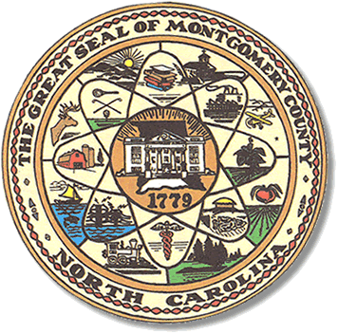

Montgomery County
Board of Elections

Karen Blair, Chairperson
John Adams, Vice Chair
Debbie Burris, Secretary

Dree Wynkoop, Member
Tasha Medley, Member

BOARD MEETING MINUTES
APRIL 12, 2022
5:00 p.m.

The Montgomery County Board of Elections (BOE) met Tuesday, April 12, 2022 at
5:00 p.m. at the BOE Office at 327 Main St in Troy, NC. Present were: Dree Wynkoop, Tasha Medley, Debbie Burris. John Adams and Karen Blair via ZOOM. Also present were the Director of Elections, Rhonda Johnson and the Deputy Director Kim Batten.

Karen Blair called the meeting to order at 5:02 p.m.

The agenda was approved for the April 12, 2022 meeting. Dree Wynkoop made a motion to approve the agenda and Tasha Medley seconded the motion. All were in favor.

The minutes from past board meeting were approved. John Adams motioned to approve the minutes and Dree Wynkoop seconded the motion. All were in favor.

There were no absentee ballots to review.

Rhonda Johnson advised board members that voters would have a number line to text if they had questions. Tasha asked how was this going to be publicized. Rhonda Johnson let the board know it would be on banners at each one stop location and on the scrolling screens in Troy and Mt. Gilead.

Rhonda Johnson advised the board the NCDHHS would be sending safety supplies for all of the precincts to have on Election Day.

Rhonda informed the board members that she has asked Neil Badour at the NCSBOE to conduct an audit on the school redistricting that was done at the first of the year. Karen asked why the state board was involved. Rhonda stated that this was due to candidates calling in questioning the accuracy of the school district changes, after reading the Montgomery Herold that encouraged them to check on the accuracy of the work completed by the Board of Elections.

There were no public comments.

With no further business at hand, and no other comments Debbie Burris moved to adjourn the meeting with a second from Dree Wynkoop. All were in favor and the meeting was adjourned at 5:28 p.m.

________________________________________ CHAIR

________________________________________ VICE CHAIR

________________________________________ MEMBER

________________________________________ MEMBER

________________________________________ MEMBER
Montgomery County Board of Elections

