**Montgomery County Board of Elections**

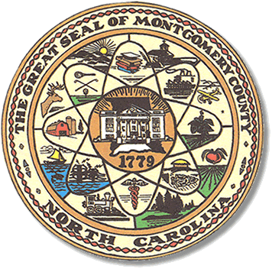

Teddi Benson Chairperson

John Adams, Secretary

Debbie Burris, Member

Dree Wynkoop, Member

Tasha Medley, Member

**BOARD MEETING AGENDA**

**Tuesday, January 14, 2025**

**5:30 pm**

Call to Order

-Approval of the Agenda

-Approval of December 10, 2024, Minutes

-Deputy Director Report

**Old Business**

-FMLA for Director Rhonda Johnson ends on January 15, 2025

-Finalize September 10, 2024, Minutes Signatures

-Final Payroll for Precinct Officials assisting in the recount have been distributed

-Assistance from the Board is needed to finalize minutes from November 14th, 15th and 21st.

**New Business**

-Upcoming Conference Information

-Incident Report Summaries from 2024 General Election

-Protest Update

-Move to Deny 3 Voter Registrations that are currently serving a Felony Sentence

-Discussion and approval of Montgomery County Board of Elections Fee Schedule

Current Fee Schedule that was posted in front entrance is from 2020

-Approval for Deputy Director to cancel ZOOM subscription-We use Microsoft Teams

-Noncitizen process update

-Legislative Updates

-Board Appointments

-Election Process Changes

-2025 Calendar

-2025 Election Preview

-Deputy Director Kimberly M Walter has requested a closed session.

**Adjournment**

**ALL BOE Meetings to be held in the Montgomery County Board of Elections office unless otherwise noted.