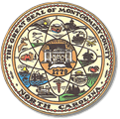

**BOARD MEETING AGENDA**

Tuesday, May 13, 2025

Regular Board Meeting 5:30 p.m.

**Call to Order**

* Approval of the Agenda
* Review and Approval of Minutes from April 8, 2025
* Director’s Report

**Old Business**

* Budget Deadline Met
* Precinct Official Stars Appreciation/Recruitment was a Success

**Public Comment**

Limit to 5 minutes

**New Business**

* Notice of Election for November 2025 Municipal Approval
* What is expected of the Director for the July 22 swearing in of Board members?

**Adjournment**